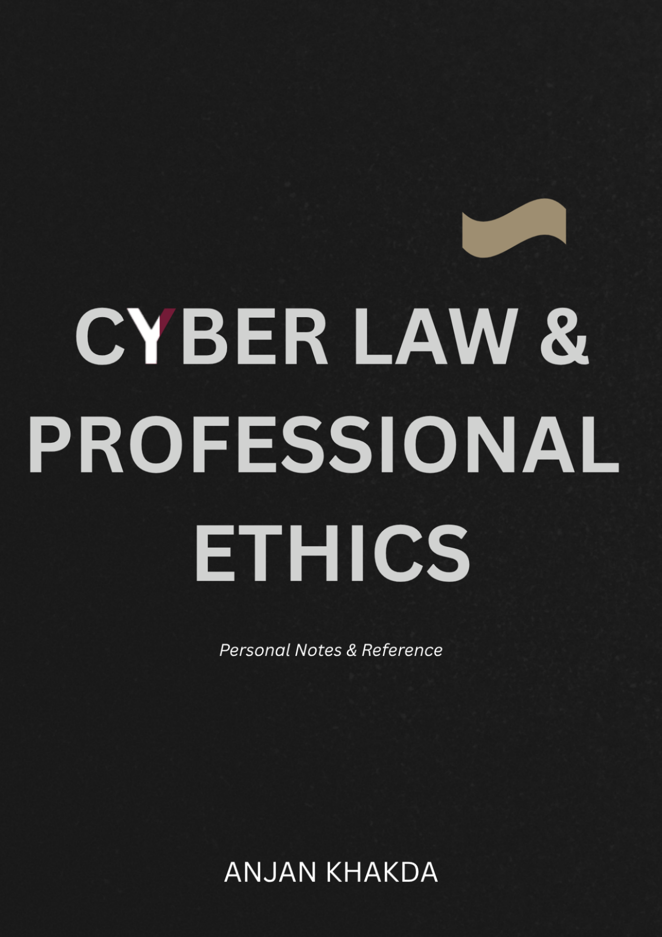
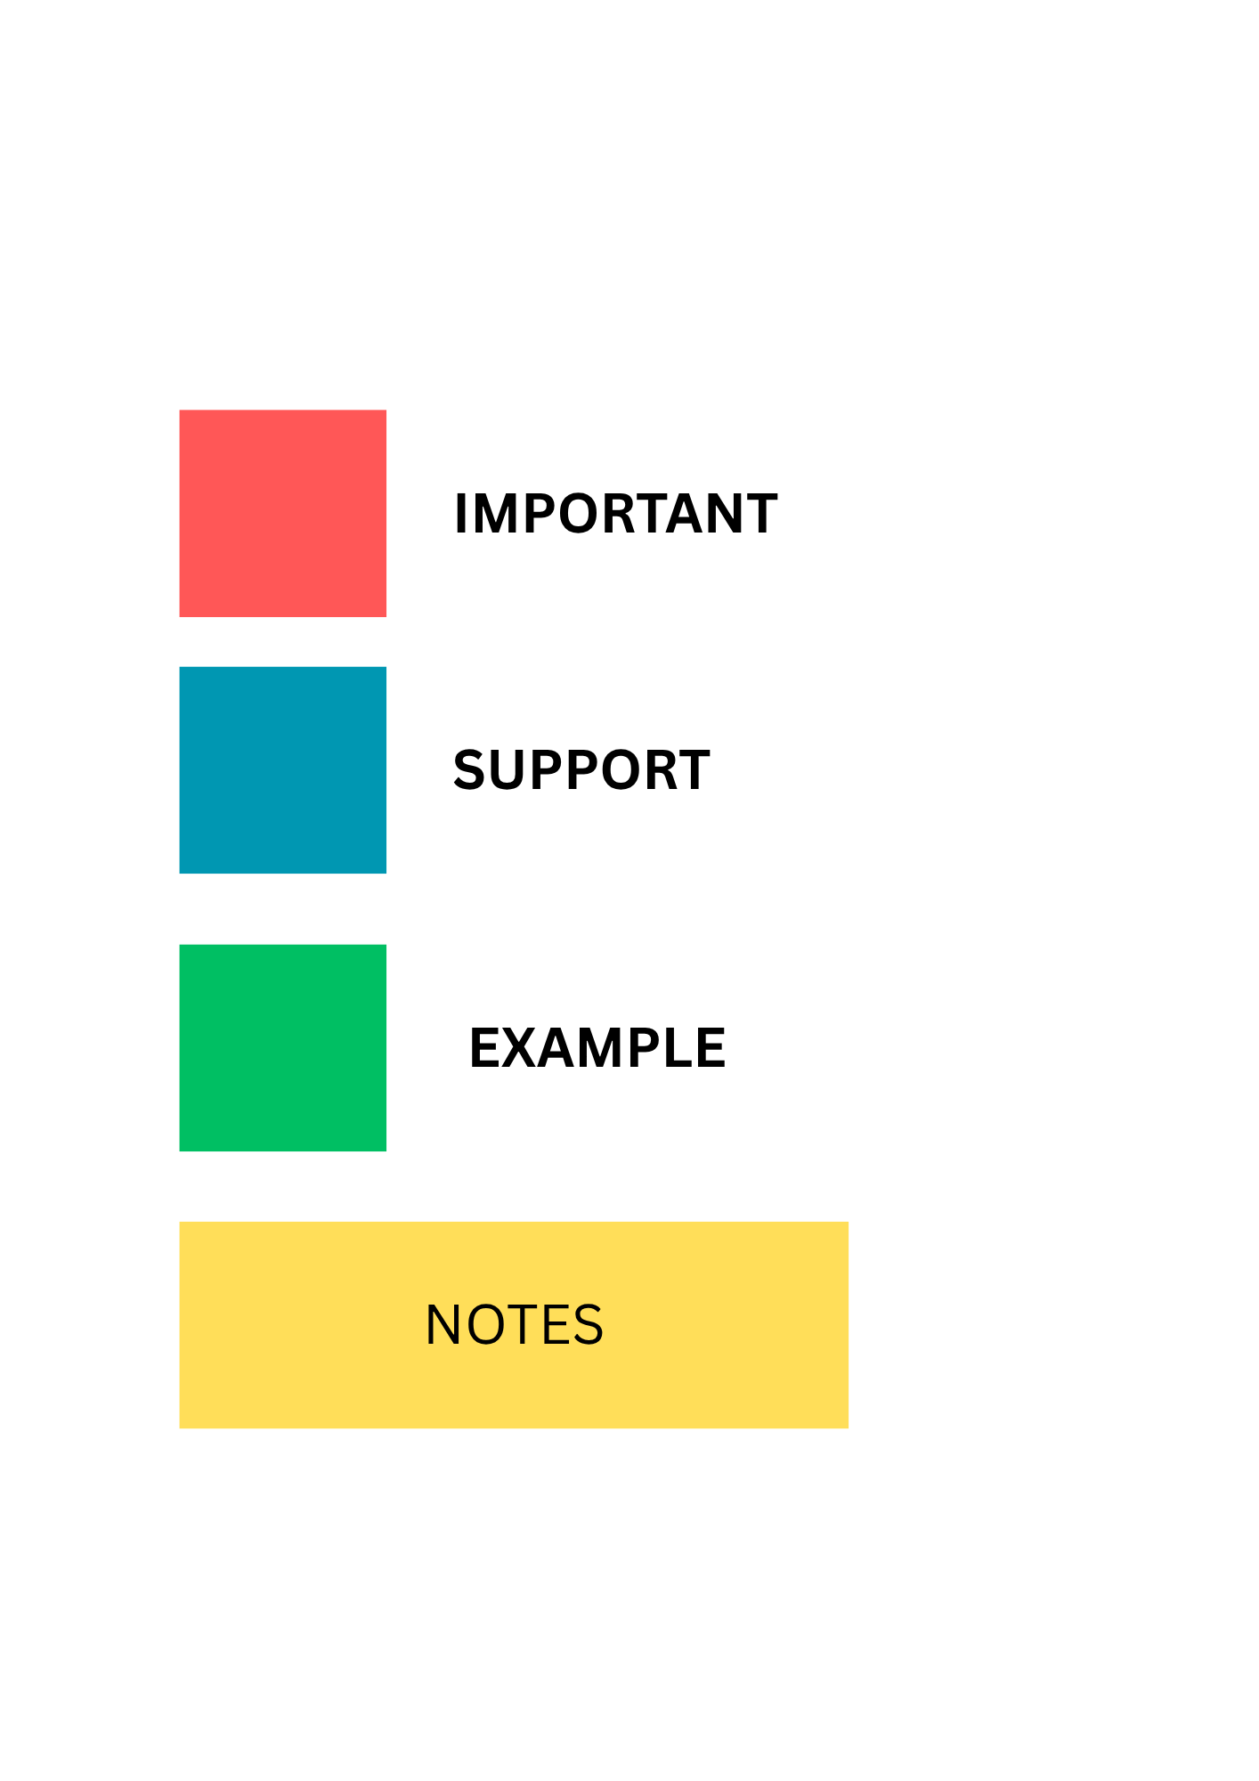

Table of Contents
READ. THESE. ARTICLES. OR SUFFER. 💀🔥 6
1. CIA Security Triad 7
2. Intellectual Property 8
3. Digital Signature 8
4. Computer Forensics & Cyberattack Response 9
5. Plagiarism 9
6. Green Computing 10
7. Phishing 11
8. ACM Code of Ethics. 12
9. A short glance at cyber law and data security in Nepal 12
10. When Was Cyber Law Introduced in Nepal? 13
11. Police use April Fool’s stunt to warn against digital scams 14
12. Cyber law vs Freedom of Expression 15
13. How social media is becoming a double-edged sword for public safety 15
14. Government asks Meta, TikTok to remove graphic flood content, misinformation 16
15. 5 funny cybersecurity incidents and what they teach us 17
16. Laughter in the dark: Tales of absurdity from the cyber frontline and what they taught us 17
17. Cyber bureau warns internet users of rising cases of phishing 18
18. Nepal Police warn of scams targeting flood relief donations 19
QUESTIONS AND ANSWERS 20
1.What is Business Ethics? What are the Reasons to Pursue CSR and Good Business Ethics? 20
2. Define Intellectual Property. How Can We Protect Such Property Using Copyright? 23
3. What is a Digital Signature? Explain Its Purpose. 25
4. Explain the Concept of Intellectual Property Rights 27
5. What is Computer Forensic? Write About Response to Cyber Attack. 29
6. Explain Any Two Ethical Issues Related to Information Technology 31
7. What is SLAPP? Explain Under What Conditions One Might Employ a SLAPP. 33
8. What is CIA Security Triad? Explain How Can We Implement CIA at the Organizational Level and Network Level. 34
9. Explain the IT Act / Cyber Law Framework in Detail. Discuss Its Objectives and Major Provisions Related to Cyber Crimes and Electronic Transactions. 37
10. What are the Challenges and Benefits of Using Internet Anonymously? What are the Key Issues Related to Freedom of Expression? 41
11. Differentiate Between Ethics and Morals. Why Is Fostering Good Business Ethics Important? 45
12. Explain Cyberstalking. Why Are Professional Ethics Important in the IT Field? 47
13. What Are the Essential Ethical Considerations in Decision-Making Systems? 50
14. What Are Some of the Key Issues That Must Be Considered When Trying to Determine if Material on the Internet Is Obscene? 52
15. What is Plagiarism? Write Its Types. 54
16. CMMI Model 56
17. Reverse Engineering 59
18. Contingent Workers 61
19. Define Whistle-Blower. How Can You Implement CIA at Network, Application and End User Level? 63
20. What Are Some of the Current Issues Associated with the Protection of Intellectual Property? 66
21. Explain the Concept of Cyber Defamation. What Are the Current Social Networking Ethical Issues? 69
22. What is H-1B Visa? Differentiate Between IT Security Audit and Risk Assessment. 71
23. Explain Different Cyber Law Provisions Available in Nepal 73
24. What is Intrusion Detection System? List and Explain Different Stages Involved in the E-Discovery Process. 76
25. What Is Internet Censorship and How Does It Work? 78
26. Explain Cybersquatting and Its Types. How Can Anyone Tackle the Cybersquatting Issue? 81
27. Why Is Green Computing a Key Issue for Multinational Companies at Present? 84
28. What is Cybercrime? Explain Different Types of Cyber Crime with Their Countermeasures. 87
29. What is Freedom of Expression? Explain the Key Issues Related to Freedom of Expression with Suitable Examples. 91
30. Explain Decision-Making Process in Brief 94
31. Explain Different Social Networking Ethical Issues in Brief 95
32. How Can You Develop High-Quality Software? Explain the Importance of Software Quality. 98
33. Acceptable Use Policy (AUP) 101
34. Phishing 103
35. Why Are Computer Incidents So Prevalent? Explain. 105
36. What Are the Challenges and Benefits of Using the Internet Anonymously? 108

READ. THESE. ARTICLES. OR SUFFER. 💀🔥
These aren’t some boring filler pages shoved in to make the notes look thicker than your last situationship excuses. There’s an actual goddamn reason they exist.
They slam you with real-world chaos, juicy scandals, practical slap-in-the-face situations, and explanations so simple even your group project freeloader could understand them — so Cyber Law and Professional Ethics finally stop being abstract torture and start making sense in the actual world.
Q&A notes will help you pass the exam.
These articles will make sure you don’t sound like a complete clown when someone asks why any of this matters. 🤡
Do NOT treat this section like optional reading you can skip faster than a phishing link screaming “FREE iPHONE + FREE DATA”.
Sit your ass down.
Open the page.
Read them. Properly.
They’ll sharpen your brain, hand you exam-ready examples on a silver platter, and burn the hard concepts so deep into your skull that even a final-semester hangover + all-nighter combo can’t erase them.
Skip them → stay average.
Read them → become dangerously good.
Your move. 😈

Author Note:
Written by someone who’s tired of watching students skip the good shit and then cry in the exam hall. You’re welcome. Now go read the damn articles. 😈

1. CIA Security Triad
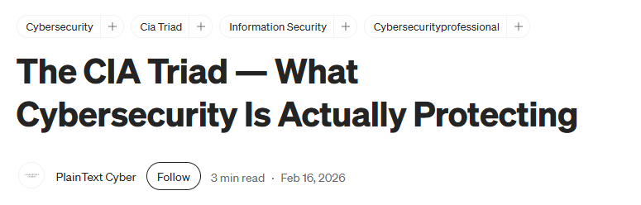
The CIA Triad is basically the three bodyguards of information: Confidentiality makes sure the wrong people don't see your data, Integrity makes sure nobody secretly changes it, and Availability makes sure the system is actually there when you need it. In short: “Don’t show it, don’t mess with it, and don’t disappear when I need you.” The second article goes a little deeper into how these principles connect with authentication, encryption, hashing, access control and other security mechanisms.
Link: https://medium.com/%40plaintextcyber/the-cia-triad-what-cybersecurity-is-actually-protecting-c858842cdee9
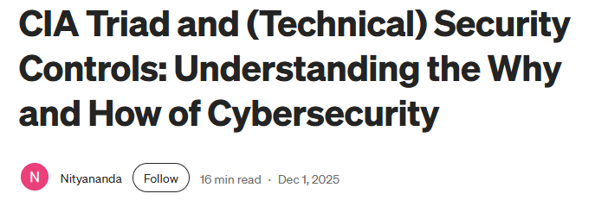
Link: https://mappedarch.medium.com/confidentiality-integrity-availability-authentication-non-repudiation-d2f4eb2f8c28

2. Intellectual Property
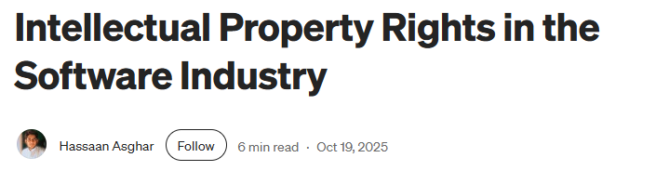
Intellectual Property is basically “I made it, so please don't casually steal it.” The article explains how software, designs, inventions, logos, ideas and other creative work can be protected through copyright, patents, trademarks and trade secrets. It also shows why IP protection matters in the software industry, where copying someone's work can sometimes be as easy as Ctrl+C → Ctrl+V.
Link: https://medium.com/%40hassaanasghar2020/intellectual-property-rights-in-the-software-industry-4f174324b72d

3. Digital Signature

A digital signature is like a cryptographic version of signing your name, except a pen and fancy handwriting are replaced by mathematics. It helps prove who sent a digital document, ensures that the document has not been secretly modified, and provides non-repudiation. Basically, it tells the receiver: “Yes, I really signed this—and no, I didn't change it halfway through.”
Link: https://medium.com/%40boutnaru/the-cryptography-concept-journey-digital-signature-63bacd12e39d

4. Computer Forensics & Cyberattack Response
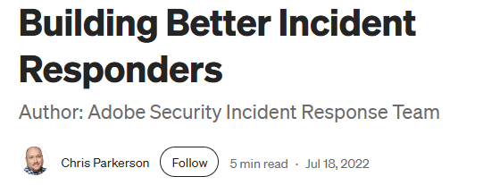
Incident responders are basically the digital firefighters and detectives of an organization. When an attack happens, they investigate what happened, identify the affected systems, preserve evidence, contain the damage and help prevent the same disaster from happening again. The article also highlights that good incident response requires preparation, teamwork and calm decision-making—because “PANIC AND DELETE EVERYTHING” is not an official cybersecurity strategy.
Link: https://medium.com/adobetech/building-better-incident-responders-9c106c79861a

5. Plagiarism

Plagiarism is more than simply copying and pasting someone's paragraph. It can also include copying ideas too closely, paraphrasing without proper attribution, mixing copied pieces together, or presenting someone else's work as your own. Medium's guidelines make the point that changing a few words doesn't magically turn “someone else's work” into “my brilliant original masterpiece.”
Link: https://help.medium.com/hc/en-us/articles/360041640213-Plagiarism-Guidelines

6. Green Computing
Green computing is about making technology less hungry for electricity and less harmful to the planet. It includes energy-efficient hardware, efficient software, responsible data-center practices, recycling and reducing electronic waste. The basic idea is simple: we love technology, but perhaps we don't need to make the planet suffer every time we open another Chrome tab.
The second article looks at green IT from a broader perspective, connecting sustainability with modern computing infrastructure, resilience and the growing environmental impact of our increasingly connected digital world.


Link: https://medium.com/%40ranugithihansa1/how-sustainable-technology-and-green-computing-can-reduce-your-carbon-footprint-ffa5c3965d5

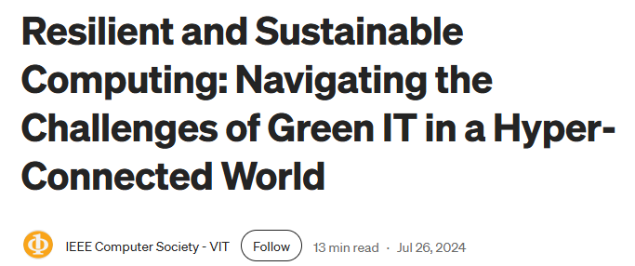
Link: https://medium.com/%40IEEE_Computer_Society_VIT/resilient-and-sustainable-computing-navigating-the-challenges-of-green-it-in-a-hyper-connected-1e16f19866b8

7. Phishing
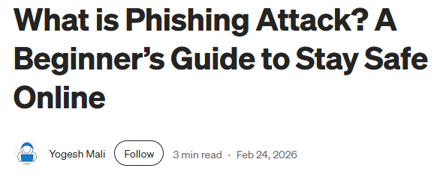
Phishing is basically digital fishing, except the fish are your passwords, bank details and personal information. Attackers create fake emails, websites, messages or alerts that look trustworthy and try to convince people to click a link or reveal sensitive information. The article explains common phishing techniques, warning signs and ways users can avoid becoming the person who says, “But the email looked so real!”
Link: https://yogeshmali01.medium.com/what-is-phishing-attack-a-beginners-guide-to-stay-safe-online-45d148c9bad9

8. ACM Code of Ethics.

The ACM Code of Ethics is essentially a rulebook for behaving like a responsible computer professional. It emphasizes avoiding harm, being honest, protecting privacy, respecting confidentiality, maintaining professional competence and considering the wider consequences of technology. In simple terms: just because you can build something doesn't automatically mean you should build it—and definitely don't build it while pretending you know what you're doing.
Link: https://www.acm.org/binaries/content/assets/about/acm-code-of-ethics-booklet.pdf

9. A short glance at cyber law and data security in Nepal
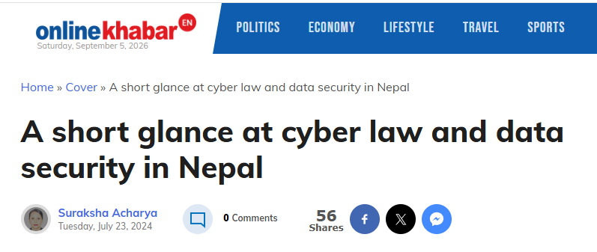
This article provides a relatively simple introduction to Nepal's cyber-law and data-security environment. It connects everyday digital activities—such as using websites, social media and electronic transactions—with issues of privacy, security, intellectual property and cybercrime. It is useful because it turns the rather scary phrase “cyber law” into things that actually happen when ordinary people use the internet in Nepal.
Link: https://english.onlinekhabar.com/a-short-glance-at-cyber-law-and-data-security-in-nepal.html

10. When Was Cyber Law Introduced in Nepal?
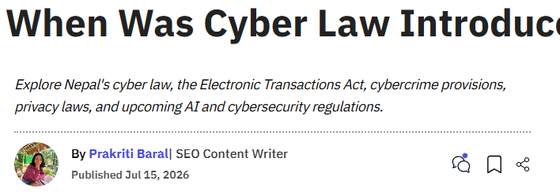
This article gives a short historical journey of cyber law in Nepal and explains how the country moved toward dedicated legislation for electronic transactions and cyber-related offences. It provides useful background to the Electronic Transactions Act and helps answer the obvious question: “Wait, what did Nepal do before all this internet-and-cybercrime madness?” It is particularly useful for understanding the development of Nepal's cyber-law framework.
Link: https://www.gadgetbytenepal.com/cyber-law-introduction-in-nepal/

11. Police use April Fool’s stunt to warn against digital scams

Nepal Police used an April Fool's stunt to demonstrate how easily people can be attracted to suspicious messages and QR codes. The clever part is that the police essentially used a scam-like trick to teach people how scams work. It is funny, but it also raises an interesting ethical question: how far can authorities go when using deception for cybersecurity awareness?
Link: https://kathmandupost.com/national/2026/04/01/police-use-april-fool-s-stunt-to-warn-against-digital-scams

12. Cyber law vs Freedom of Expression
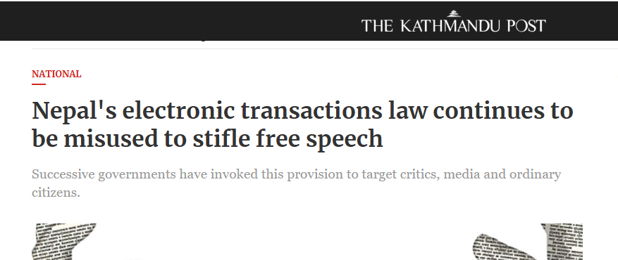
This article explores the tension between controlling harmful online activities and protecting people's freedom of expression. Nepal's cyber-law framework can become complicated when online posts, criticism, satire or other forms of expression come into conflict with legal restrictions. The interesting question is not simply “Is this post legal?”, but rather “Where exactly should society draw the line between protection and censorship?”
Link: https://kathmandupost.com/national/2026/04/29/nepal-s-electronic-transactions-law-continues-to-be-misused-to-stifle-free-speech

13. How social media is becoming a double-edged sword for public safety
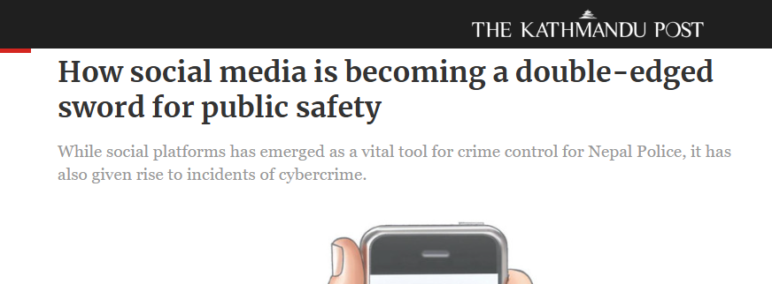
Social media is basically a Swiss Army knife with no instruction manual—the same platform can help people during emergencies while also being used for scams, misinformation and other harmful activities. This article discusses how social media can assist public safety and investigations while simultaneously creating new problems. Technology itself isn't automatically good or bad; what people do with it is the real plot twist.
Link: https://kathmandupost.com/national/2025/08/28/how-social-media-is-becoming-a-double-edged-sword-for-public-safety

14. Government asks Meta, TikTok to remove graphic flood content, misinformation
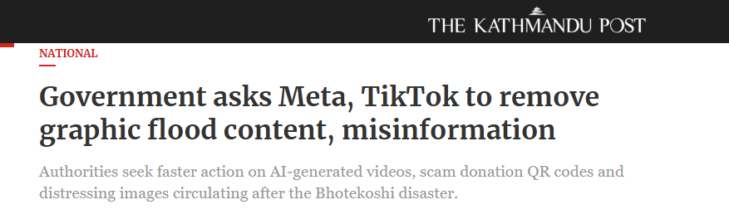
This article shows how social media becomes particularly problematic during disasters, when fake information, manipulated content, fraudulent QR codes and graphic material can spread quickly. The government sought action from major platforms to address harmful content related to the floods. It provides a modern example of the difficult balance between freedom of expression, public safety, misinformation and platform responsibility.
Link: https://kathmandupost.com/national/2026/08/28/government-asks-meta-tiktok-to-remove-graphic-flood-content-misinformation

15. 5 funny cybersecurity incidents and what they teach us

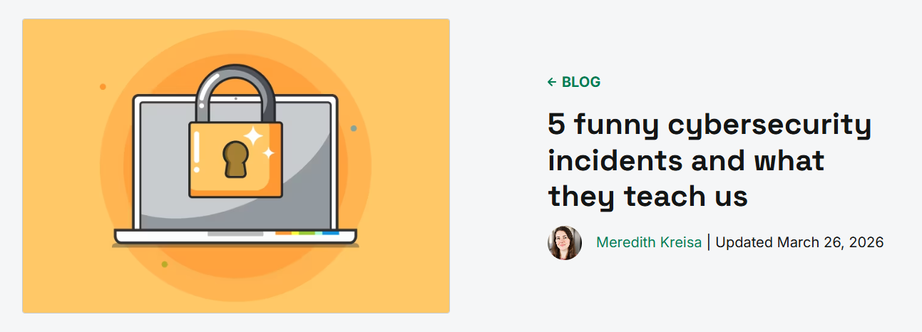
This article collects strange and amusing cybersecurity incidents that sound almost too ridiculous to be real. Behind the comedy, however, are serious lessons about weak security, human mistakes, poor configurations and unexpected attack surfaces. It is a good reminder that cybersecurity incidents don't always look like a mysterious hacker in a dark room typing at 300 words per minute—sometimes humans simply make wonderfully terrible decisions.
Link: https://www.pdq.com/blog/funny-cybersecurity-incidents/

16. Laughter in the dark: Tales of absurdity from the cyber frontline and what they taught us
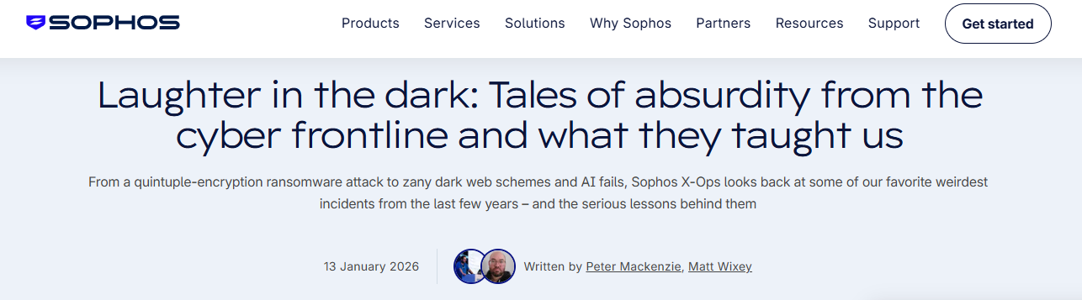
This collection looks at some of the stranger and more absurd situations encountered in cybersecurity. The stories show that cyberattacks can involve bizarre human behaviour, unexpected mistakes and situations that would sound like comedy if they weren't actually security incidents. It is useful because the stories demonstrate an important lesson: cybersecurity is not only about sophisticated technology; humans are often the most unpredictable part of the system.
Link: https://www.sophos.com/en-gb/blog/laughter-in-the-dark-tales-of-absurdity

17. Cyber bureau warns internet users of rising cases of phishing
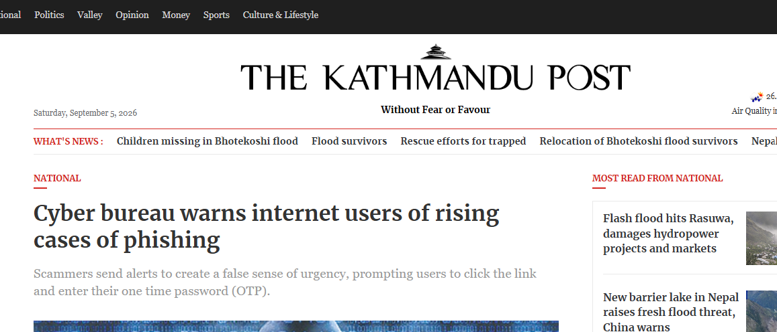
This Nepal-specific article discusses the increasing use of phishing scams involving fake loan offers, investment or stock-market opportunities, software alerts and fraudulent banking messages. The attackers rely heavily on trust and urgency rather than complicated technical attacks. In other words, sometimes the hacker doesn't need to break your computer—they just need to convince you to open the door for them.
Link: https://kathmandupost.com/national/2025/04/11/cyber-bureau-warns-internet-users-of-rising-cases-of-phishing

18. Nepal Police warn of scams targeting flood relief donations
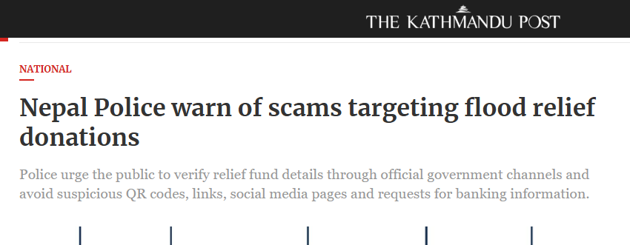
This article describes scams exploiting people's willingness to help during disasters. Fraudsters can create fake donation pages, misuse the names or logos of organizations and provide fraudulent QR codes to collect money or information. It is a particularly good example of how cybercriminals exploit human emotions such as sympathy and urgency—because apparently even disaster relief needs a cybersecurity department.
Link: https://kathmandupost.com/national/2026/08/27/nepal-police-warn-of-scams-targeting-flood-relief-donations

QUESTIONS AND ANSWERS

1.What is Business Ethics? What are the Reasons to Pursue CSR and Good Business Ethics?
Business ethics refers to the moral principles, values, and standards that guide the behavior and decision-making of a business organization. It determines what is right or wrong, fair or unfair, and acceptable or unacceptable in business activities. Business ethics applies to areas such as dealing with customers, employees, competitors, suppliers, shareholders, government, and society.
Good business ethics means conducting business with honesty, fairness, integrity, transparency, accountability, and respect for others. An ethical business does not focus only on earning profit but also considers the effects of its decisions on stakeholders and society. Thus, business ethics helps an organization achieve its objectives in a responsible and sustainable manner.
Following are the reasons to Pursue CSR and Good Business Ethics:
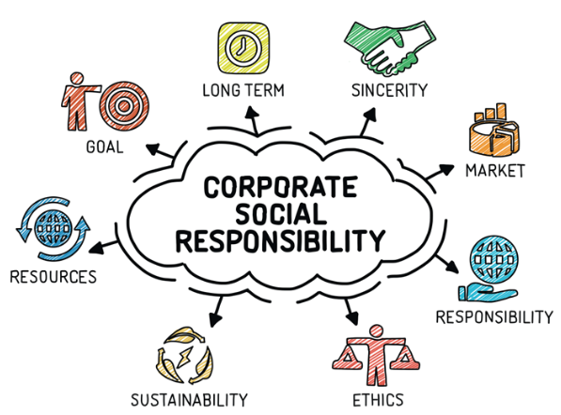
Corporate Social Responsibility (CSR) is the responsibility of a business to consider its impact on society and the environment while carrying out its business activities. Businesses pursue CSR and good business ethics for several important reasons.
1. Builds trust and reputation
Ethical behavior and CSR help an organization develop a positive reputation among customers, employees, investors, and the general public. When a company acts honestly and responsibly, stakeholders are more likely to trust it. A good reputation can become an important competitive advantage for the organization.
2. Increases customer loyalty
Customers increasingly prefer businesses that treat people fairly, provide quality products and services, and care about social and environmental issues. Ethical practices and CSR activities can therefore increase customer satisfaction and loyalty. This helps the organization maintain long-term relationships with its customers.
3. Improves employee commitment
Employees are more likely to feel motivated and committed when they work for an organization that treats them fairly and respects their rights. Ethical workplaces promote fairness, equality, safety, and dignity. CSR and ethical practices can therefore improve employee morale, productivity, and retention.
4. Supports long-term business success
Unethical practices may provide short-term benefits but can lead to legal penalties, financial losses, damaged reputation, and loss of customers. In contrast, ethical business practices encourage sustainable decision-making and reduce unnecessary risks. Therefore, CSR and business ethics contribute to the long-term success and stability of an organization.
5. Helps fulfill social responsibility
Businesses operate within society and use various social resources such as labor, infrastructure, natural resources, and public services. CSR encourages businesses to give something back to society through activities such as education, community development, environmental protection, and social welfare. This creates a more positive relationship between business and society.
6. Protects the environment
CSR encourages organizations to consider the environmental consequences of their activities. Businesses can reduce pollution, manage waste, conserve resources, and adopt environmentally responsible practices. Such actions help protect natural resources and support sustainable development.
7. Ensures legal and ethical compliance
Good business ethics encourages organizations to follow laws, regulations, professional standards, and accepted moral principles. It helps prevent activities such as fraud, corruption, discrimination, exploitation, and misleading advertising. As a result, businesses can reduce legal and ethical risks.
Business ethics provides the moral foundation for responsible business behavior, while CSR extends this responsibility toward society and the environment. Pursuing CSR and good business ethics helps businesses build trust, maintain a good reputation, satisfy customers and employees, reduce risks, protect the environment, and achieve sustainable long-term success. Therefore, ethical and socially responsible business practices are important not only for society but also for the continued growth and success of the organization.

2. Define Intellectual Property. How Can We Protect Such Property Using Copyright?
Intellectual Property (IP) refers to creations of the human mind that have legal and economic value. It includes creations such as inventions, literary and artistic works, computer programs, designs, symbols, names, and images used in business. Unlike physical property, intellectual property is mainly based on ideas and creative work, and the creator or owner can receive legal rights over its use.

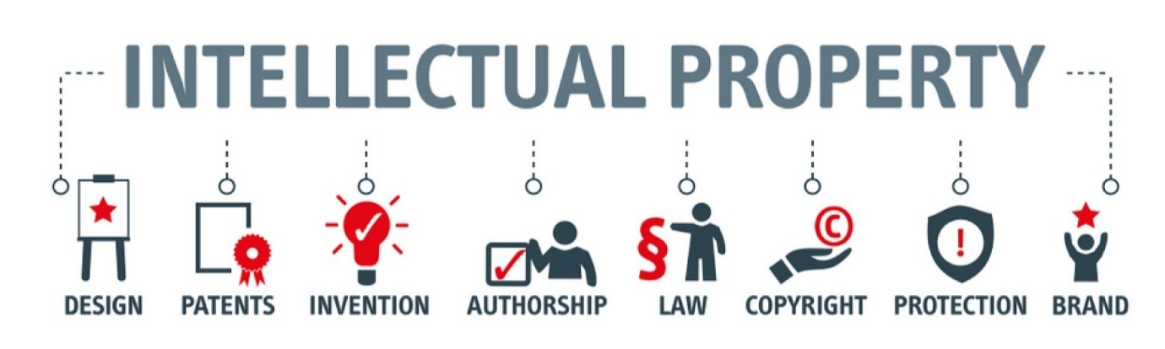
Intellectual property protection gives creators and owners the ability to control how their creations are used, copied, distributed, or commercially exploited. It also encourages people and organizations to create new works because their efforts can receive legal and economic protection.
Protection of Intellectual Property Using Copyright
Copyright is a legal protection given to the original expression of an idea, particularly in literary, artistic, and creative works. In the context of computer and information technology, copyright can protect software, source code, databases, websites, digital content, documentation, graphics, photographs, and other original works. Copyright generally protects the way an idea is expressed rather than the underlying idea itself.
Following are the ways intellectual property can be protected using copyright:
1. Protecting original creative works
Copyright gives legal protection to original works created by an individual or organization. For example, a programmer's original source code, a writer's book, or an artist's digital artwork can be protected from unauthorized copying or use.
2. Preventing unauthorized copying
The copyright owner has the right to control the reproduction of the protected work. Other people cannot legally copy substantial parts of the work without permission, subject to applicable legal exceptions. This helps prevent unauthorized duplication and distribution.
3. Controlling distribution and publication
Copyright allows the owner to control how a protected work is published, distributed, or made available to the public. For example, the owner of software can decide whether it will be distributed commercially, provided freely, or licensed to particular users.
4. Controlling modification and adaptation
Copyright can protect against unauthorized modification or adaptation of a protected work. For example, a person cannot simply take copyrighted software, substantially modify it, and distribute the resulting work without considering the copyright owner's rights and applicable exceptions.
5. Using licensing agreements
The owner can give others permission to use copyrighted property through a license. A license can specify who can use the work, how it can be used, and under what conditions. This allows the owner to earn income while still maintaining ownership of the intellectual property.
6. Taking legal action against infringement
When someone uses, copies, distributes, or exploits copyrighted material without proper authorization, the copyright owner may use the legal remedies available under the applicable copyright law. Such remedies help protect the owner's economic and legal interests.
Intellectual property represents valuable creations of the human mind, and its protection is important for encouraging creativity, innovation, and economic development. Copyright provides an important means of protecting original creative works by giving their owners control over copying, distribution, publication, adaptation, and authorized use. Therefore, proper use of copyright helps creators receive recognition and economic benefit from their work while discouraging unauthorized exploitation.

3. What is a Digital Signature? Explain Its Purpose.
A digital signature is an electronic method used to verify the identity of the sender and the authenticity of a digital message or document. It is created using cryptographic techniques, mainly a pair of keys called a private key and a public key. The sender uses the private key to create the digital signature, while the receiver can use the corresponding public key to verify it.
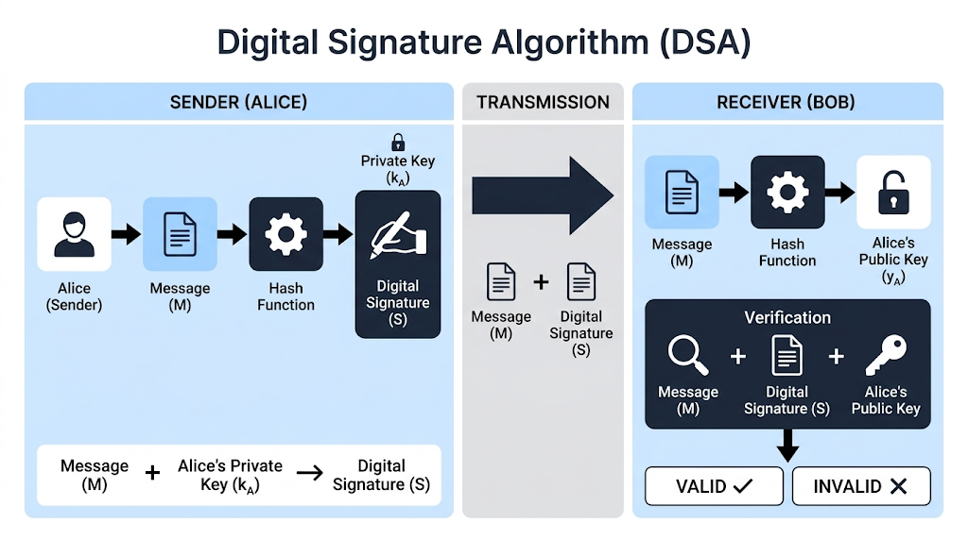
A digital signature is different from a scanned image of a handwritten signature. It provides security features that help determine whether a digital document was actually signed by the claimed person and whether the document was changed after it was signed. It is commonly used in electronic documents, online transactions, digital contracts, and electronic communication.
Purpose of Digital Signature
1. Authentication
A digital signature helps verify the identity of the person or organization that signed a digital document. This provides confidence that the document came from the claimed sender and reduces the possibility of impersonation.
2. Ensures data integrity
A digital signature helps detect whether the original document or message has been changed after signing. If the content is modified, the signature verification will fail, indicating that the document may have been altered.
3. Provides non-repudiation
Digital signatures provide evidence that a particular person or organization signed a document. This makes it more difficult for the signer to later deny having signed the document, subject to the applicable legal and technical requirements.
4. Provides security in electronic transactions
Digital signatures increase trust in online transactions by allowing parties to verify the identity of the signer and the integrity of electronic documents. They are therefore useful in areas such as online banking, electronic contracts, e-government services, and business transactions.
5. Reduces the need for physical documents
Digital signatures allow documents to be signed electronically without printing, physically signing, scanning, and sending them. This saves time, cost, paper, and administrative effort, particularly when documents need to be exchanged between people in different locations.
A digital signature is a cryptographic technique used to authenticate the signer and protect the integrity of a digital document or message. Its main purposes are authentication, data integrity, non-repudiation, and secure electronic transactions. Therefore, digital signatures play an important role in creating trust and security in electronic communication and digital transactions.

4. Explain the Concept of Intellectual Property Rights
Intellectual Property Rights (IPR) are legal rights given to a person or organization over creations of the human mind. These creations may include inventions, literary and artistic works, computer programs, designs, symbols, names, and other original creations. IPR gives the creator or owner certain rights to use, control, protect, and gain economic benefit from their intellectual creation.
The main purpose of intellectual property rights is to protect creators from the unauthorized use or exploitation of their work. At the same time, IPR encourages people and organizations to create, innovate, and invest in new ideas because they receive legal protection for their efforts. In the field of information technology, IPR is particularly important for protecting software, databases, digital content, computer-related inventions, and creative digital works.
Major Forms of Intellectual Property Rights
1. Copyright
Copyright protects original literary, artistic, and creative works. In the IT field, it can protect computer programs, source code, websites, databases, digital graphics, and other original digital content. It gives the owner rights over activities such as copying, distribution, and adaptation, subject to applicable legal exceptions.
2. Patent
A patent provides legal protection for a new and useful invention that meets the requirements of patent law. It gives the patent owner exclusive rights over the invention for a specified period. Patents mainly encourage technological innovation by protecting inventions from unauthorized commercial use.
3. Trademark
A trademark protects a name, logo, symbol, word, or other sign that identifies the goods or services of a particular business. It helps customers distinguish one business or product from another and protects the business identity and reputation associated with the mark.
4. Trade Secret
A trade secret refers to valuable business information that is kept confidential and provides a competitive advantage. Examples include source code, algorithms, formulas, business strategies, customer information, and technical processes. Protection depends largely on taking reasonable measures to maintain its secrecy.
5. Industrial Design
Industrial design protection covers the visual or aesthetic appearance of a product, such as its shape, pattern, configuration, or appearance. It allows the owner to prevent unauthorized commercial use of a protected design.
IPR provides creators with an opportunity to receive recognition and financial benefits from their work. It also protects businesses from unfair copying and helps them maintain their competitive advantage. For society, effective IPR encourages innovation, creativity, research, and technological development by providing legal protection to new ideas and creations.
Conclusion: Intellectual Property Rights provide a legal framework for protecting creative and innovative works from unauthorized use. Copyright, patents, trademarks, trade secrets, and industrial designs protect different forms of intellectual property. Therefore, IPR is important for protecting the interests of creators and businesses while encouraging innovation, creativity, fair competition, and economic development.

5. What is Computer Forensic? Write About Response to Cyber Attack.
Computer forensics is the process of identifying, collecting, preserving, examining, and analyzing digital evidence from computers and other digital devices. It is used to investigate cybercrimes, security incidents, unauthorized access, data theft, malware attacks, and other activities involving digital systems. The main purpose of computer forensics is to find out what happened, how the incident occurred, who may have been responsible, and what evidence can support the investigation.
Computer forensic investigation must be carried out carefully so that digital evidence is not changed, damaged, or destroyed. Evidence may be collected from computers, hard drives, mobile devices, servers, network logs, emails, and other digital sources. Proper documentation and preservation of evidence are important because forensic evidence may also be used in legal proceedings.
Response to Cyber Attack
A cyber attack response is the systematic process of dealing with a cyber attack after it is detected. The main objectives are to control the attack, reduce damage, recover affected systems, and prevent similar attacks in the future.
1. Identify and assess the attack
The first step is to detect the attack and understand its nature and scope. The organization should determine which systems, accounts, networks, or data have been affected. Logs, security alerts, and other available information can help identify the source and impact of the incident.
2. Contain the attack
After identifying the affected systems, immediate steps should be taken to prevent the attack from spreading. Compromised devices or accounts may be isolated from the network, and affected services may be temporarily restricted. The goal is to stop further unauthorized access and reduce additional damage.
3. Preserve evidence
Relevant digital evidence should be preserved before systems are cleaned or restored. This may include system logs, network records, files, emails, and other forensic information. Evidence should be collected and handled properly so that it remains reliable for further investigation or legal purposes.
4. Remove the cause of the attack
Once the attack has been contained, the organization should identify and remove the source of the compromise, such as malware, unauthorized accounts, or vulnerable software. Security weaknesses that allowed the attacker to enter the system should also be corrected.
5. Recover the systems
Affected systems should be restored to a secure and normal working condition. Clean backups may be used where necessary, and systems should be tested carefully before returning them to normal operation. Passwords and other security credentials should also be changed when they may have been compromised.
6. Report and investigate the incident
The incident should be properly documented and reported to the responsible management, security team, or relevant authorities when required. A detailed investigation helps determine how the attack happened, what information was affected, and whether further action is necessary.
7. Prevent future attacks
After recovery, the organization should review the incident and improve its security measures. This may include updating software, strengthening access controls, improving monitoring, training employees, and developing better incident-response procedures. Learning from the attack helps reduce the possibility and impact of future incidents.
Computer forensics helps investigate cyber incidents by collecting and analyzing digital evidence, while cyber attack response focuses on controlling the incident and restoring secure operations. A proper response involves identifying the attack, containing it, preserving evidence, removing the threat, recovering systems, investigating the incident, and improving security. Together, computer forensics and effective incident response help organizations reduce damage and deal with cyber attacks in a systematic and responsible manner.

6. Explain Any Two Ethical Issues Related to Information Technology
Ethical issues in Information Technology (IT) arise when the use of computers, software, networks, and digital information creates questions about what is right, fair, responsible, and acceptable. IT has made information easier to collect, store, process, and share, but its misuse can harm individuals, organizations, and society. Therefore, IT professionals and users must consider the ethical consequences of their actions, not only whether something is technically possible.
Two important ethical issues related to information technology are privacy and confidentiality and intellectual property and software piracy.
1. Privacy and Confidentiality
Privacy is the right of individuals to control their personal information and decide how it is collected, used, and shared. IT systems can store large amounts of personal data such as names, addresses, financial details, health information, passwords, and online activities. The ethical issue arises when such information is collected or used without proper knowledge, consent, or justification.
Organizations have a responsibility to protect personal information from unauthorized access, misuse, or unnecessary disclosure. For example, selling customer information without proper permission or accessing an employee's private data without a valid reason can violate privacy. Therefore, organizations should collect only necessary information, use it responsibly, keep it secure, and respect the privacy of individuals.
2. Intellectual Property and Software Piracy
Intellectual property refers to creations of the human mind, such as software, digital content, designs, inventions, and written works. The ethical issue occurs when people copy, distribute, modify, or use such creations without the permission of the owner. Software piracy is a common example, where copyrighted software is illegally copied or distributed.
Unauthorized use of intellectual property is unfair to the creator because it can result in loss of income, recognition, and control over the work. IT users and professionals should respect copyright, licenses, patents, and other intellectual property rights. Using legally obtained software and giving proper credit to creators are important parts of ethical behavior in IT.
Conclusion: Privacy and intellectual property are important ethical issues because technology gives people powerful ways to access, store, copy, and share information. Responsible IT use requires respecting individuals' privacy and protecting the rights of creators. By following ethical principles along with applicable laws and professional standards, IT professionals can use technology in a way that benefits both organizations and society.

7. What is SLAPP? Explain Under What Conditions One Might Employ a SLAPP.
SLAPP stands for Strategic Lawsuit Against Public Participation. It is a legal action mainly used to intimidate, silence, or discourage a person or group from speaking about matters of public interest. A SLAPP may be filed against journalists, activists, researchers, whistleblowers, community groups, or ordinary individuals who criticize a company, organization, or powerful person.
The main concern with a SLAPP is not necessarily winning the case. Instead, the legal process itself may be used to create financial pressure, stress, delay, or fear so that the targeted person stops speaking, reporting, protesting, or participating in a public debate. Therefore, SLAPPs are generally considered a threat to freedom of expression and public participation.
Conditions Under Which One Might Employ a SLAPP
A person or organization might employ a SLAPP when the primary purpose is to discourage or punish public participation rather than to genuinely resolve a legal dispute. Common situations include:
1. Criticism of a business or organization
A company may bring a lawsuit against a person who publicly criticizes its products, services, business practices, or conduct. The purpose may be to make the person withdraw the criticism or avoid making further statements.
2. Public discussion of controversial issues
A SLAPP may be used when an individual or organization participates in a public debate about an issue affecting society. Legal action can be used to create pressure on the person so that they stop expressing their views.
3. Investigative journalism or reporting
Journalists may face legal action after publishing information about alleged wrongdoing, corruption, environmental harm, or other matters of public concern. A powerful party may use the cost and pressure of litigation to discourage further investigation or reporting.
4. Activism or protest
Organizations or individuals involved in protests, campaigns, or social movements may become targets of SLAPP lawsuits. The legal action may be intended to discourage them from continuing their activities or encouraging others to participate.
5. Whistleblowing
A person who reveals suspected misconduct or illegal activity may be threatened with legal action. If the action is mainly intended to frighten the whistleblower into remaining silent, it can have the characteristics of a SLAPP.
A SLAPP is a lawsuit used as a tool to discourage public participation and freedom of expression, rather than simply to obtain a legitimate legal remedy. It may be employed against people who criticize organizations, report matters of public interest, participate in protests, or expose suspected wrongdoing. Such actions can create fear and financial pressure and may weaken open public discussion. Therefore, recognizing and preventing abusive lawsuits is important for protecting freedom of expression and democratic participation.

8. What is CIA Security Triad? Explain How Can We Implement CIA at the Organizational Level and Network Level.
The CIA security triad is a basic information security model consisting of Confidentiality, Integrity, and Availability. These three principles are used to protect information and information systems from unauthorized access, improper modification, and disruption. An organization needs all three because information is useful only when it is kept private when necessary, remains accurate and trustworthy, and is available to authorized users when required.
Confidentiality means protecting information from unauthorized access or disclosure. Integrity means ensuring that information remains accurate, complete, and unchanged except by authorized users. Availability means ensuring that authorized users can access information and services whenever they are needed. Together, these principles provide a foundation for designing and managing information security.
Implementation of CIA at the Organizational Level
At the organizational level, the CIA triad is implemented through policies, procedures, employee practices, technical controls, and management decisions.
1. Implementing Confidentiality
Organizations can protect confidentiality by controlling who is allowed to access sensitive information. This can be done through user authentication, strong passwords, multi-factor authentication, role-based access control, and data encryption. Employees should receive only the level of access required for their job. Confidential information should also be protected through proper data-handling policies and employee awareness training.
2. Implementing Integrity
Integrity can be maintained by ensuring that organizational information cannot be changed without proper authorization. Organizations can use access controls, file permissions, digital signatures, audit logs, checksums, and version control to detect or prevent unauthorized changes. Regular monitoring also helps identify suspicious modifications to important data.
3. Implementing Availability
Availability can be maintained by ensuring that systems and information remain accessible during normal operations and unexpected incidents. Organizations can use regular backups, redundant systems, disaster recovery plans, UPS or backup power, system maintenance, and emergency response procedures. These measures help the organization continue its important activities even when hardware failure, cyber attacks, or other disruptions occur.
Implementation of CIA at the Network Level
At the network level, the CIA triad is implemented by protecting network devices, communication channels, servers, and data moving across the network.
1. Implementing Confidentiality
Network confidentiality can be achieved by preventing unauthorized users from accessing network resources and by protecting data during transmission. Firewalls, network access controls, encryption, VPNs, secure communication protocols, and authentication mechanisms can be used to control access and protect sensitive information from interception.
2. Implementing Integrity
Network integrity ensures that information transmitted through the network is not secretly modified or manipulated. Organizations can use secure communication protocols, digital signatures, message authentication, integrity checks, and network monitoring to detect unauthorized changes. Intrusion detection and prevention systems can also help identify suspicious network activities.
3. Implementing Availability
Network availability means keeping network services and resources accessible to authorized users. This can be supported through redundant network connections, load balancing, backup systems, proper network monitoring, DDoS protection, and fault-tolerant network devices. Regular maintenance and quick response to network failures also help maintain availability.
The CIA security triad provides a fundamental framework for protecting information and information systems. Confidentiality protects information from unauthorized access, integrity protects it from unauthorized modification, and availability ensures that authorized users can access it when needed. At the organizational level, these principles are implemented through policies, access controls, employee awareness, backups, and recovery plans. At the network level, they are supported through firewalls, encryption, authentication, monitoring, redundancy, and other network security controls. Therefore, applying all three principles together helps an organization maintain a secure, reliable, and trustworthy information environment.

9. Explain the IT Act / Cyber Law Framework in Detail. Discuss Its Objectives and Major Provisions Related to Cyber Crimes and Electronic Transactions.
The IT Act / Cyber Law framework refers to the legal rules and regulations that govern the use of computers, computer networks, electronic records, digital communication, and online transactions. In Nepal, the main law governing these matters is the Electronic Transactions Act, 2063 (2008). It provides legal recognition to electronic records and digital signatures and establishes legal provisions for dealing with various computer-related offenses. The Act is an important part of Nepal's cyber law framework because it attempts to create a secure and legally recognized environment for electronic activities.
Cyber law is important because traditional laws were mainly designed for physical documents, face-to-face transactions, and physical forms of evidence. With the growth of the internet and digital technology, activities such as online transactions, electronic contracts, unauthorized access, data manipulation, and online fraud require appropriate legal treatment. The IT Act and related cyber laws therefore provide a legal basis for regulating electronic activities and addressing misuse of information technology.
Objectives of the IT Act / Cyber Law Framework
1. To provide legal recognition to electronic records
One of the major objectives is to give electronic records legal validity. Documents stored or transmitted electronically can be recognized as legally meaningful rather than requiring every transaction to depend on paper documents.
2. To provide legal recognition to digital signatures
The framework provides legal recognition to digital signatures and establishes a system for their use in electronic transactions. Digital signatures help verify the identity of the signer and the integrity of an electronic document.
3. To facilitate electronic transactions
The law aims to encourage the use of electronic methods for business, communication, government services, and other transactions. By providing legal recognition to electronic records and signatures, it creates greater confidence in digital transactions.
4. To control cyber crimes
Another major objective is to address crimes committed using computers, computer systems, and electronic communication. The law provides offenses and penalties for various forms of unauthorized or harmful activities involving information technology.
5. To create a secure digital environment
Cyber law helps establish rules for responsible use of information technology. It seeks to protect individuals, businesses, and government systems from misuse and supports safer electronic communication and transactions.
Major Provisions Related to Electronic Transactions
1. Legal recognition of electronic records
The law recognizes electronic records so that information does not lose its legal validity merely because it exists in electronic form. This supports the use of electronic documents in business, government, and other activities.
2. Legal recognition of digital signatures
Digital signatures are legally recognized for authenticating electronic documents. A digital signature provides a way to verify the identity of the signer and helps establish that the document has not been improperly altered after signing.
3. Digital Signature Certificates and Certifying Authorities
The framework provides for the regulation of digital signatures and certifying authorities. Certifying authorities can issue digital signature certificates and perform functions necessary for establishing trust in electronic authentication.
4. Electronic filing and electronic communication
The legal recognition of electronic records makes it possible for government agencies and organizations to use electronic methods for submitting, storing, and communicating information. This supports the development of electronic governance and paperless services.
5. Rules relating to electronic transactions
The framework establishes a legal basis for conducting transactions through electronic means. This is important for activities such as electronic business, online services, and other forms of digital communication where parties may not be physically present.
Major Provisions Related to Cyber Crimes
The Electronic Transactions Act also identifies various activities involving computers and electronic systems as offenses and provides penalties for them.
1. Unauthorized access
Accessing a computer, computer system, or network without proper authorization is treated as a cyber offense. This provision helps protect systems from unauthorized users attempting to obtain access to information or services.
2. Damage or alteration of computer data
Unauthorized deletion, alteration, damage, or destruction of computer data can constitute an offense. Such activities can affect the integrity and reliability of digital information and may cause significant financial or operational loss.
3. Damage to computer systems
Interfering with or damaging a computer system can also attract legal consequences. This covers activities that disrupt the normal functioning of computer systems or make them unavailable to authorized users.
4. Publication of illegal or prohibited materials
The Act contains provisions concerning the publication and display of prohibited materials in electronic form. These provisions are intended to regulate certain harmful or unlawful content distributed through electronic means.
5. Computer-related fraud
Using computers or electronic systems to commit fraud or obtain an unlawful benefit can result in criminal liability. This provision is important because technology can be used to manipulate electronic information or transactions for financial or other gain.
6. Breach of confidentiality
Unauthorized disclosure or misuse of information obtained through access to computer systems may also result in legal consequences. This helps protect confidential information from improper disclosure.
7. Abetment and related offenses
The framework can also apply to people who assist, encourage, or participate in the commission of certain cyber offenses. Therefore, responsibility is not necessarily limited to the person who directly performs the technical act.
Investigation, Adjudication and Penalties
The cyber law framework also establishes mechanisms for investigating and handling cyber-related offenses. Authorized bodies can investigate offenses, collect relevant evidence, and take legal action according to the law. The framework also provides mechanisms for adjudication and appeal in matters covered by the Act.
Depending on the nature and seriousness of the offense, a person found guilty may face fines, imprisonment, or both, as provided by the applicable law. The availability of legal penalties helps discourage unauthorized access, data manipulation, fraud, and other forms of cybercrime.
Importance of the IT Act / Cyber Law Framework
The framework is important because it creates legal certainty for electronic activities and provides mechanisms for addressing misuse of technology. It supports electronic commerce and digital government while also establishing responsibilities and penalties for harmful activities. However, cyber law must continuously develop because technologies, cyber threats, and methods of committing digital crimes change over time.
Conclusion
The IT Act and cyber law framework provide the legal foundation for conducting and regulating activities in the digital environment. In Nepal, the Electronic Transactions Act, 2063 (2008) is a major component of this framework. Its provisions give legal recognition to electronic records and digital signatures, support electronic transactions, regulate digital authentication, and address offenses such as unauthorized access, data or system damage, illegal publication, computer-related fraud, and breach of confidentiality. Overall, the framework aims to promote secure electronic transactions, control cybercrime, protect digital information, and build trust in the use of information technology.

10. What are the Challenges and Benefits of Using Internet Anonymously? What are the Key Issues Related to Freedom of Expression?
Internet anonymity means using the internet without revealing one's real identity or by hiding identifying information such as name, location, or other personal details. A person may use anonymous accounts, privacy tools, or other methods to communicate and participate online without directly connecting their online activities to their real-world identity. Anonymity can protect people from harm and support free communication, but it can also make it easier to misuse the internet.
Freedom of expression is the right of individuals to express their opinions, ideas, beliefs, and information. The internet has greatly expanded this freedom because people can communicate with a large audience quickly and easily. However, freedom of expression is not unlimited. Issues arise when online expression conflicts with privacy, reputation, public safety, or the rights of other people.
Benefits of Using the Internet Anonymously
1. Protection of privacy
Anonymity allows individuals to communicate and browse the internet without unnecessarily revealing their identity. This can reduce unwanted tracking, profiling, and exposure of personal information.
2. Freedom to express opinions
People may feel more comfortable sharing honest opinions when their real identity is protected. This can be particularly useful when discussing sensitive or controversial subjects.
3. Protection from harassment or retaliation
Anonymous communication can protect people who may face threats, discrimination, social pressure, or retaliation because of their opinions or activities. Journalists, whistleblowers, and people discussing sensitive issues may benefit from anonymity.
4. Safer access to sensitive information
People may use anonymity when seeking information about sensitive personal, social, or political matters. It can allow them to obtain information without unnecessarily exposing their identity.
Challenges of Using the Internet Anonymously
1. Cybercrime and misuse
Anonymity can make it easier for some people to engage in illegal activities such as fraud, cyberbullying, hacking, harassment, or distribution of harmful content. The ability to hide identity can reduce the fear of immediate identification.
2. Difficulty in identifying offenders
When an online user hides their identity, investigating harmful or criminal activities can become more difficult. Law enforcement may need additional technical and legal procedures to identify the person responsible.
3. False information and fake identities
Anonymous users can create fake accounts or spread false information without immediately revealing who they are. This can contribute to misinformation, manipulation, and damage to the reputation of individuals or organizations.
4. Lack of accountability
Anonymity can reduce accountability because a person may believe that they will not face consequences for harmful online behavior. This can encourage irresponsible comments, threats, harassment, or other unethical activities.
Key Issues Related to Freedom of Expression
1. Freedom of speech vs. harmful content
People should generally be able to express their opinions, but freedom of expression can create problems when speech involves threats, incitement to violence, serious harassment, or other unlawful content. The challenge is to protect legitimate expression while preventing genuine harm.
2. Defamation and protection of reputation
Freedom of expression may conflict with a person's right to protect their reputation. Publishing false and damaging statements about another person can cause serious personal and professional harm. Therefore, the right to express opinions must be balanced with responsibility for harmful false claims.
3. Privacy
Freedom of expression does not automatically give someone the right to publish another person's private information. Sharing personal data, photographs, or confidential information without proper justification can violate privacy and cause harm.
4. Censorship and government control
Governments may restrict online content for reasons such as national security, public order, or prevention of illegal activities. However, excessive censorship can suppress legitimate criticism and prevent people from freely discussing important social and political issues.
5. Hate speech and discrimination
Online platforms can be used to spread content that attacks individuals or groups based on characteristics such as religion, ethnicity, gender, or other identity-related factors. The challenge is to address harmful discriminatory content without unnecessarily restricting legitimate discussion and opinion.
6. Responsibility of online platforms
Social media and other online platforms must decide how to deal with harmful or unlawful content while respecting users' freedom of expression. Excessive removal may silence legitimate opinions, while insufficient moderation may allow serious abuse and harmful content to spread.
Conclusion: Internet anonymity provides important benefits such as privacy, protection from retaliation, and greater freedom to express sensitive opinions, but it can also create challenges involving cybercrime, misinformation, fake identities, and lack of accountability. Similarly, freedom of expression is essential for an open society, but it must be balanced with privacy, reputation, public safety, and the rights of others. Therefore, the responsible use of anonymity and freedom of expression requires a balance between individual rights, social responsibility, and applicable law.

11. Differentiate Between Ethics and Morals. Why Is Fostering Good Business Ethics Important?
Ethics and morals are both concerned with determining what is right and wrong, but they are not exactly the same. Morals are the personal beliefs and values that an individual develops about right and wrong, often influenced by family, culture, religion, and personal experiences. Ethics, on the other hand, refers to more systematic principles and standards that guide behavior within a profession, organization, or society.
In business, ethics provides a common standard for making responsible decisions and dealing fairly with employees, customers, competitors, and other stakeholders. While an individual's morals may differ from another person's, business ethics helps organizations establish expected standards of professional behavior.
Basis | Ethics | Morals
Meaning | Ethics refers to principles and standards used to determine appropriate and responsible behavior. | Morals refer to an individual's personal beliefs about what is right and wrong.
Source | Ethics may come from professional standards, organizational rules, laws, and accepted social principles. | Morals are mainly influenced by family, culture, religion, education, and personal experiences.
Nature | Ethics is generally more systematic and can be formally defined through codes and rules. | Morals are more personal and may differ from one individual to another.
Application | Ethics often guides behavior in a particular profession, organization, or social setting. | Morals guide an individual's behavior and personal decisions in everyday life.
Example | A business employee maintaining customer confidentiality according to professional standards is following an ethical principle. | A person believing that lying is wrong and choosing not to lie reflects a personal moral belief.

Importance of Fostering Good Business Ethics
1. Builds trust and reputation
Good business ethics helps an organization develop trust among customers, employees, investors, and the public. Honest and fair business practices create a positive reputation, which can become a valuable long-term asset for the organization.
2. Improves customer relationships
When a business provides accurate information, maintains product quality, treats customers fairly, and protects their information, customers are more likely to trust the organization. This can increase customer satisfaction and loyalty.
3. Creates a positive work environment
Ethical organizations promote fairness, respect, equality, and responsibility among employees. Such an environment improves employee morale and can encourage greater commitment and productivity.
4. Reduces legal and business risks
Unethical behavior such as fraud, corruption, discrimination, or misuse of confidential information can result in legal penalties and financial losses. Strong ethical standards help employees understand acceptable behavior and reduce the likelihood of such problems.
5. Supports long-term success
Unethical actions may sometimes provide short-term benefits, but they can seriously damage an organization's reputation and relationships. Good business ethics encourages responsible decisions that support sustainable growth and long-term success.
6. Promotes social responsibility
Businesses have an impact on customers, employees, communities, and the environment. Ethical practices encourage organizations to consider these effects rather than focusing only on profit. This helps create a responsible relationship between business and society.
Conclusion: Ethics provides systematic standards for responsible behavior, while morals are mainly based on an individual's personal beliefs about right and wrong. In business, fostering good ethics is important because it builds trust, improves relationships, creates a positive workplace, reduces risks, and supports long-term success. Therefore, strong business ethics is an essential part of a responsible and sustainable organization.

12. Explain Cyberstalking. Why Are Professional Ethics Important in the IT Field?
Cyberstalking is the repeated use of the internet, computers, mobile phones, social media, email, or other digital technologies to monitor, threaten, harass, intimidate, or disturb another person. Unlike ordinary online communication, cyberstalking usually involves repeated and unwanted behavior that causes fear, stress, or a feeling of being unsafe. A cyberstalker may repeatedly send unwanted messages, monitor someone's online activities, create fake accounts, spread personal information, or make threats.
Cyberstalking can seriously affect the victim's privacy, mental well-being, reputation, and personal safety. Because digital communication can be carried out from a distance and sometimes through fake identities, identifying the person responsible can be difficult. Cyberstalking may also involve other forms of cyber abuse, such as identity misuse, unauthorized access, harassment, or sharing private information without permission.
Common Forms of Cyberstalking
1. Repeated unwanted communication
A cyberstalker may continuously send unwanted emails, messages, comments, or calls even after the victim has asked them to stop. Repeated communication can create fear and emotional pressure.
2. Monitoring online activities
The stalker may constantly monitor a person's social media accounts, online presence, posts, or activities. In more serious cases, they may attempt to obtain unauthorized access to accounts or personal information.
3. Threats and intimidation
Cyberstalking may involve threatening messages or other attempts to frighten the victim. Such threats can create serious concerns about the victim's personal safety.
4. Fake accounts and impersonation
A cyberstalker may create fake social media profiles using another person's name or photographs. These accounts can be used to contact others, damage the victim's reputation, or continue harassment.
Importance of Professional Ethics in the IT Field
Professional ethics are the principles and standards that guide IT professionals to behave responsibly, honestly, and fairly while performing their professional duties. IT professionals have access to powerful technologies and large amounts of information, so their decisions can directly affect individuals, organizations, and society.
1. Protects privacy and confidential information
IT professionals often have access to personal and organizational data. Ethical behavior requires them to keep such information confidential and prevent unauthorized access, disclosure, or misuse.
2. Prevents misuse of technology
IT skills can be used for both beneficial and harmful purposes. Professional ethics helps IT professionals avoid activities such as unauthorized access, data theft, malware distribution, cyberstalking, and other forms of technological abuse.
3. Maintains trust
Organizations and users depend on IT professionals to manage systems and information responsibly. Honesty, confidentiality, and accountability help build trust between professionals, organizations, and users.
4. Promotes responsible decision-making
IT professionals may face situations where a technically possible action is not ethically acceptable. Professional ethics provides principles for considering the possible effects of their decisions on users, organizations, and society.
5. Protects the quality and reliability of IT systems
Ethical professionals are expected to perform their work carefully and honestly. They should not intentionally hide serious errors, manipulate information, or compromise system security. This contributes to reliable and secure IT services.
6. Supports legal and professional compliance
Professional ethics encourages IT professionals to respect laws, regulations, intellectual property rights, privacy requirements, and professional standards. This helps reduce legal problems and promotes responsible use of technology.
Conclusion: Cyberstalking is a serious form of online harassment in which technology is repeatedly used to monitor, threaten, intimidate, or disturb another person. Professional ethics is equally important in IT because professionals have significant access to technology and sensitive information. By following ethical principles, IT professionals can protect privacy, prevent misuse of technology, maintain trust, make responsible decisions, and support secure and reliable IT systems.

13. What Are the Essential Ethical Considerations in Decision-Making Systems?
A decision-making system is a system that helps or automatically makes decisions by using data, rules, algorithms, or artificial intelligence. Such systems are increasingly used in areas such as banking, healthcare, education, employment, security, and business. Since these systems can directly affect people's rights, opportunities, privacy, and well-being, ethical considerations are necessary to ensure that decisions are made fairly, responsibly, transparently, and without causing unnecessary harm.
The ethical design of a decision-making system requires consideration not only of whether the system works correctly, but also of how its decisions affect people and society. The following are the major ethical considerations.
1. Fairness and Non-Discrimination
A decision-making system should treat people fairly and should not produce unjustified discrimination based on characteristics such as gender, race, religion, age, or other protected or sensitive attributes. Bias can enter a system through the data used to train it, the rules used to make decisions, or the way the system is designed. Therefore, organizations should regularly check systems for unfair outcomes and take steps to reduce bias.
2. Privacy and Data Protection
Decision-making systems often require large amounts of personal information. Ethical use requires that personal data be collected and used only for legitimate purposes and protected from unauthorized access or disclosure. Individuals should have reasonable knowledge of how their information is being used, particularly when sensitive information is involved.
3. Transparency and Explainability
People affected by an important automated decision should, where appropriate, be able to understand how and why the decision was made. A system should not operate as a completely unexplained "black box" when its decisions have significant consequences. Clear explanations also help organizations identify errors and allow affected individuals to question questionable decisions.
4. Accountability
There should always be a clear person or organization responsible for the decisions and outcomes of a decision-making system. Organizations should not avoid responsibility by simply blaming the software or algorithm. Proper records, monitoring, auditing, and responsibility mechanisms should be established to determine who is accountable when the system makes an error or causes harm.
5. Accuracy and Reliability
A decision-making system should provide accurate and reliable results. Incorrect or outdated data can lead to wrong decisions, which may cause serious consequences for individuals or organizations. Systems should therefore be properly tested, regularly monitored, and updated when necessary.
6. Human Oversight
For decisions that can significantly affect people's lives, human involvement is important. A qualified person should be able to review, question, or override an automated decision when necessary. Human oversight helps deal with unusual situations and reduces the risk of blindly accepting an incorrect system output.
7. Security
Decision-making systems must be protected against unauthorized access, manipulation, and cyber attacks. If attackers can change the data or manipulate the system, its decisions may become unreliable or harmful. Strong authentication, access controls, encryption, monitoring, and other security measures can help protect the system.
8. Respect for Human Rights and Social Welfare
A decision-making system should respect basic human rights and should be designed to provide benefits without causing unnecessary harm. Before deploying a system, organizations should consider its possible effects on individuals, communities, and society. Technology should support human well-being rather than treating people merely as data or numbers.
Conclusion: Ethical decision-making systems should be designed and used with fairness, privacy, transparency, accountability, accuracy, human oversight, security, and respect for human rights. These considerations help ensure that technology is not only technically effective but also socially responsible. Therefore, ethical principles should be considered throughout the entire life cycle of a decision-making system, from its design and development to its use and continuous monitoring.

14. What Are Some of the Key Issues That Must Be Considered When Trying to Determine if Material on the Internet Is Obscene?
Internet obscenity refers to online material that is considered excessively offensive, sexually explicit, or inappropriate according to applicable legal and social standards. Determining whether material is obscene is difficult because the internet allows content to cross national and cultural boundaries, while different societies have different views about what is acceptable. Therefore, deciding whether online material is obscene requires consideration of both the nature of the content and its legal and social context.
The issue is also connected with freedom of expression. Not every offensive, sexual, or controversial material is necessarily legally obscene. A proper determination should consider the content as a whole, its purpose, its likely audience, and the applicable law rather than judging it only from a small part of the material.
Key Issues to Consider
1. Nature and content of the material
The first consideration is what the material actually contains. The level of sexual explicitness, the way sexual acts are presented, and whether the material is intended primarily to sexually arouse or exploit are important factors. The content should generally be examined as a whole rather than based on a single word, image, or scene.
2. Applicable law and legal standards
Obscenity is primarily a legal concept, so the applicable law must be considered. Different countries and jurisdictions may have different definitions and standards. Material that is permitted in one country may be restricted or unlawful in another. Therefore, the location, applicable legislation, and jurisdiction involved are important.
3. Community standards
Social and community standards can influence whether material is considered acceptable or obscene. What one community considers offensive may be considered acceptable in another. Therefore, the social context and prevailing standards of the relevant community may need to be considered.
4. Purpose and artistic or educational value
The purpose of the material is important. Content containing sexual elements may have legitimate artistic, educational, scientific, medical, or literary purposes. Such material should not automatically be treated as obscene simply because it contains sexual content. The overall purpose and context should be examined.
5. Intended audience
The intended audience is another important consideration. Material created for adults may be treated differently from material that is easily accessible to children. Websites and online services should take reasonable measures where necessary to prevent inappropriate content from being accessed by minors.
6. Harm to individuals or society
The possible harm caused by the material should also be considered. This may include exploitation, abuse, harm to children, or other serious consequences. Content involving child sexual abuse or exploitation is treated much more seriously and is illegal in many jurisdictions regardless of claims about artistic or expressive value.
7. Freedom of expression
Any decision regarding online obscenity must be balanced against the right to freedom of expression. Overly broad restrictions can prevent people from accessing legitimate artistic, educational, political, or cultural content. Therefore, restrictions should be based on clear legal standards rather than simply suppressing material that someone finds personally offensive.
8. International nature of the Internet
Internet content can be created in one country, hosted in another, and accessed by users around the world. This creates difficulties in determining which country's laws and standards should apply. International differences make regulation and enforcement of online obscenity particularly challenging.
Conclusion
Determining whether Internet material is obscene is a complex issue because it involves content, purpose, audience, community standards, applicable law, possible harm, and freedom of expression. A material should not be considered obscene merely because it is controversial or offensive to some people. A careful assessment of its overall context and the relevant legal standards is necessary to distinguish legitimate expression from genuinely unlawful or harmful content.

15. What is Plagiarism? Write Its Types.
Plagiarism is the act of using another person's ideas, words, work, or creative content and presenting it as one's own without giving proper credit to the original creator. It is considered an unethical practice because it violates the creator's intellectual property and gives a false impression about who produced the work. Plagiarism can occur in academic work, research, software development, articles, websites, presentations, and other forms of digital content.
Plagiarism does not always mean copying an entire work. It can also occur when only a part of someone else's work is copied or when their ideas are used without proper acknowledgment. With the widespread availability of information on the Internet, copying and reusing digital content has become easier, making awareness of plagiarism particularly important.
Types of Plagiarism
1. Direct Plagiarism
Direct plagiarism occurs when a person copies another person's exact words or sentences without quotation marks and proper citation. The copied material is presented as if it were the person's own original writing.
2. Self-Plagiarism
Self-plagiarism occurs when a person reuses their own previously submitted or published work without properly indicating that it has been used before. For example, submitting the same assignment for two different courses without permission can be considered self-plagiarism.
3. Mosaic Plagiarism
Mosaic plagiarism occurs when a person takes words, phrases, or ideas from different sources and combines them with their own writing without properly citing those sources. The final work may appear original, but important parts have been taken from other works.
4. Paraphrasing Plagiarism
Paraphrasing plagiarism occurs when someone changes a few words or rearranges the sentence structure of another person's work but does not give credit to the original source. Simply changing the wording does not make the idea original.
5. Accidental Plagiarism
Accidental plagiarism occurs unintentionally, usually because of poor note-taking, incorrect citation, or misunderstanding of referencing rules. Although there may be no intention to deceive, proper citation is still necessary.
6. Complete Plagiarism
Complete plagiarism occurs when a person submits or presents an entire work created by someone else as their own. This is one of the most serious forms because the person takes full credit for another person's work.
Conclusion
Plagiarism is the unauthorized use or presentation of another person's work, words, or ideas as one's own. It can occur intentionally or accidentally and includes direct copying, self-plagiarism, mosaic plagiarism, paraphrasing plagiarism, accidental plagiarism, and complete plagiarism. Proper citation, quotation, paraphrasing, and acknowledgment of sources are important ways to avoid plagiarism and maintain academic and professional integrity.

16. CMMI Model
CMMI (Capability Maturity Model Integration) is a process improvement framework used by organizations to improve their processes, manage projects effectively, maintain quality, and achieve better performance. It provides a structured way to identify weaknesses in an organization's existing processes and improve them step by step. CMMI is widely associated with software and systems development, but its principles can be applied to other organizational processes as well.
The main idea of CMMI is that an organization becomes more effective when its work processes are properly planned, documented, measured, controlled, and continuously improved. Instead of depending only on individual skills or informal practices, CMMI encourages organizations to develop consistent and repeatable processes.
Maturity Levels of CMMI
CMMI traditionally describes organizational process maturity through five maturity levels:
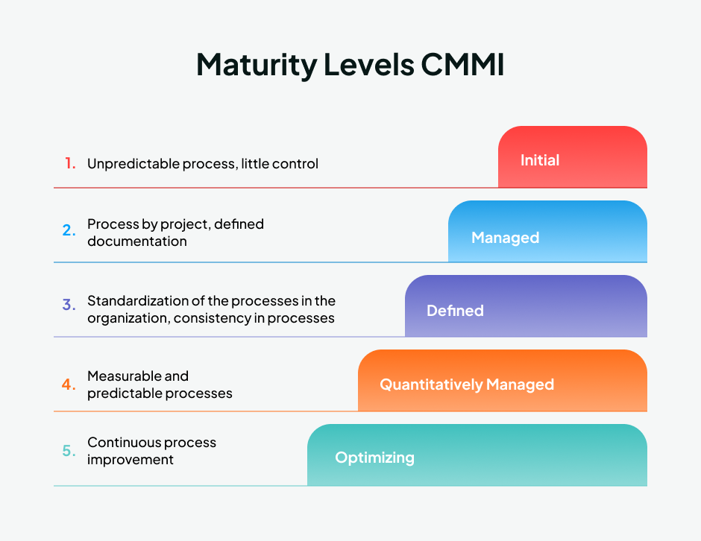
1. Initial
At the Initial level, processes are generally unpredictable and poorly controlled. The success of a project depends heavily on the skills and efforts of individual people. There may be limited planning, documentation, or standard procedures.
2. Managed
At the Managed level, projects are planned, monitored, and controlled. Organizations establish basic project management practices such as managing requirements, schedules, costs, and resources. Previous experience can also be used to manage similar projects more effectively.
3. Defined
At the Defined level, the organization establishes standard and documented processes that are used across projects. Employees follow organizational guidelines, and processes are tailored according to the needs of individual projects while maintaining organizational standards.
4. Quantitatively Managed
At this level, processes are measured and controlled using quantitative data. Organizations use statistical and other measurement techniques to understand process performance and identify whether processes are operating within expected limits.
5. Optimizing
The Optimizing level focuses on continuous process improvement. The organization identifies weaknesses, learns from experience, adopts useful innovations, and makes improvements to increase quality, efficiency, and performance.
Benefits of the CMMI Model
1. Improves process quality
CMMI helps organizations establish systematic and well-defined processes. This reduces inconsistency and improves the quality of products and services.
2. Reduces project risks
Proper planning, monitoring, measurement, and process control help organizations identify potential problems earlier and take corrective action.
3. Improves productivity
Well-organized processes reduce unnecessary work, confusion, and repeated mistakes. This allows employees to use time and resources more effectively.
4. Supports continuous improvement
CMMI encourages organizations to regularly evaluate their processes and make improvements based on experience and measurable results.
5. Increases customer satisfaction
Better-controlled processes can lead to more reliable products, improved quality, and better delivery performance, which can increase customer confidence and satisfaction.
Conclusion
CMMI is a structured framework for improving organizational processes and performance. Its five traditional maturity levels—Initial, Managed, Defined, Quantitatively Managed, and Optimizing—show the progression from informal and unpredictable processes toward measurable and continuously improving processes. By adopting CMMI practices, organizations can improve quality, productivity, risk management, consistency, and customer satisfaction.

17. Reverse Engineering
Reverse engineering is the process of examining an existing product, system, software, or technology to understand how it works, how it is designed, and how its different components are related. Instead of developing a system from the beginning, reverse engineering starts with an existing system and works backward to understand its structure, design, and functionality.
In software engineering, reverse engineering may involve analyzing an existing program, source code, database, or system to recover its design and technical information. It is useful when the original documentation or source code is unavailable or outdated. Reverse engineering should be carried out within applicable laws, licenses, contracts, and intellectual property rights.
Process of Reverse Engineering
1. Information collection
The existing system is first examined to collect available information about its functions, components, inputs, outputs, and operating environment. Existing documents and system behavior may also be studied.
2. System analysis
The internal structure and behavior of the system are analyzed to understand how different components work together. In software, this may include examining program code, data structures, interfaces, and system operations.
3. Design recovery
From the information obtained, the original design and architecture of the system are reconstructed. This helps developers understand the relationships between different parts of the system.
4. Documentation
The recovered information is organized into diagrams, specifications, source code documentation, or other technical documents. This makes the system easier to understand and maintain.
Uses of Reverse Engineering
1. Software maintenance
Reverse engineering is useful for maintaining old software when its original design documents or source code are incomplete. Developers can study the existing system before making modifications or improvements.
2. System modernization
An organization may analyze an old system to understand its functions before replacing it with a newer technology. This helps preserve important business requirements during system migration.
3. Security analysis
Security professionals may examine software and systems to identify vulnerabilities, weaknesses, malware behavior, or suspicious activities. This can help improve the security of the system.
4. Recovery of lost information
When documentation is lost or unavailable, reverse engineering can help recover information about the system's structure and operation.
5. Compatibility and integration
Reverse engineering can help developers understand how an existing system works so that another system can communicate or work with it. This is useful when integrating older systems with newer technologies.
Advantages of Reverse Engineering
Reverse engineering can reduce development effort, improve understanding of existing systems, support maintenance, identify security weaknesses, and help modernize outdated software. It can also help organizations preserve knowledge about systems that have been in use for many years.
Conclusion
Reverse engineering is a systematic process of studying an existing system to understand its design, structure, and functionality. It is particularly useful in software maintenance, security analysis, system modernization, and recovery of technical information. However, it should be performed responsibly by respecting copyright, intellectual property rights, software licenses, contracts, and applicable laws.

18. Contingent Workers
Contingent workers are individuals who work for an organization on a temporary, contractual, part-time, freelance, or project-based basis rather than as permanent employees. They are generally hired to perform specific tasks, provide specialized skills, or meet short-term workforce requirements. Unlike regular employees, contingent workers may not receive the same employment benefits, job security, or long-term employment relationship.
Contingent workers are common in the IT industry, where organizations often need professionals for specific projects such as software development, system implementation, cybersecurity, testing, technical support, or consulting. They may work independently or through a staffing agency and are usually engaged for a defined period or until a particular project is completed.
Types of Contingent Workers
1. Freelancers
Freelancers are independent professionals who provide their skills or services to organizations for particular tasks or projects. They may work with several clients at the same time.
2. Independent Contractors
Independent contractors are hired under a contract to perform specific work or provide specialized services. They generally have greater control over how they perform the work compared with regular employees.
3. Temporary Workers
Temporary workers are employed for a limited period, often to meet short-term staffing requirements or replace employees who are unavailable.
4. Consultants
Consultants provide specialized knowledge or professional advice to an organization. In IT, consultants may be hired for areas such as cybersecurity, software architecture, database management, or technology planning.
Benefits of Contingent Workers
1. Flexibility
Organizations can increase or reduce their workforce according to project requirements. This is especially useful when the need for particular skills exists only for a limited period.
2. Access to specialized skills
Organizations can hire professionals with specialized technical knowledge without permanently employing them. This is useful for complex or highly technical projects.
3. Cost management
Hiring contingent workers can reduce certain long-term employment costs because the organization does not necessarily have to maintain the same level of permanent staffing and benefits.
4. Faster hiring
Organizations can often hire experienced professionals quickly when they need additional workers for an urgent project or short-term requirement.
Ethical Issues Related to Contingent Workers
The use of contingent workers can also create ethical concerns. Organizations should provide fair treatment, clear contracts, reasonable working conditions, and proper payment. They should not use temporary employment arrangements simply to avoid responsibilities that should reasonably apply to employees. Confidential information, intellectual property, privacy, and security must also be protected when external workers are given access to organizational systems.
Conclusion
Contingent workers are temporary or non-permanent workers hired to meet specific, flexible, or short-term organizational needs. Freelancers, independent contractors, temporary workers, and consultants are common examples. They provide organizations with flexibility and access to specialized skills, particularly in the IT field. However, organizations must manage contingent workers responsibly by ensuring fair treatment, clear responsibilities, security, confidentiality, and respect for legal and ethical standards.

19. Define Whistle-Blower. How Can You Implement CIA at Network, Application and End User Level?
A whistle-blower is a person, usually an employee or member of an organization, who reports or exposes illegal, unethical, fraudulent, or harmful activities occurring within the organization. The person may report the matter to management, an authorized internal body, regulatory authorities, law enforcement, or the public, depending on the situation.
Whistle-blowing plays an important role in maintaining accountability, transparency, and professional ethics. For example, an employee who discovers financial fraud, misuse of confidential information, corruption, or a serious security violation may report it through an appropriate whistle-blowing channel. However, organizations should provide safe reporting mechanisms and protect genuine whistle-blowers from retaliation.
Implementation of CIA at Different Levels
The CIA security triad consists of Confidentiality, Integrity, and Availability. Confidentiality protects information from unauthorized access, integrity ensures that information remains accurate and is not improperly changed, and availability ensures that authorized users can access systems and information when required. These principles should be implemented at different levels of an IT environment.
1. CIA at Network Level
Confidentiality:
Network confidentiality can be maintained by controlling who can access network resources and protecting data while it travels across the network. Firewalls, VPNs, encryption, secure communication protocols, network access controls, and authentication can be used to prevent unauthorized users from accessing or intercepting sensitive information.
Integrity:
Network integrity ensures that data transmitted through the network is not secretly modified or manipulated. Organizations can use digital signatures, message authentication, secure protocols, checksums, intrusion detection systems, and network monitoring to identify unauthorized changes or suspicious activities.
Availability:
Network availability ensures that network services remain accessible to authorized users. Redundant network connections, backup devices, load balancing, DDoS protection, fault-tolerant systems, and continuous network monitoring can help reduce downtime and maintain reliable network services.
2. CIA at Application Level
Confidentiality:
Applications should ensure that users can access only the information and functions they are authorized to use. This can be achieved through user authentication, role-based access control, multi-factor authentication, encryption, and proper session management.
Integrity:
Application integrity means ensuring that data entered, processed, and stored by the application is accurate and cannot be changed improperly. Input validation, access controls, database permissions, audit logs, digital signatures, and secure software development practices can help protect application data from unauthorized modification.
Availability:
Applications should remain functional and accessible when users need them. This can be supported through regular backups, load balancing, server redundancy, error handling, performance monitoring, disaster recovery plans, and regular software maintenance. Applications should also be tested to identify failures before they seriously affect users.
3. CIA at End-User Level
Confidentiality:
End users play an important role in protecting confidential information. Users should use strong and unique passwords, multi-factor authentication, screen locks, encryption, and secure handling of sensitive files. They should also avoid sharing passwords or confidential information with unauthorized people.
Integrity:
Users should ensure that information is not accidentally or intentionally changed without authorization. They should use trusted software, avoid suspicious downloads, follow proper file-handling procedures, and report unusual changes or security incidents. Regular updates and antivirus or endpoint security tools can also help protect user devices.
Availability:
Users can help maintain availability by keeping their devices updated, using reliable security software, maintaining appropriate backups, and reporting system failures or security incidents quickly. Proper use of organizational resources also helps prevent unnecessary system disruptions.
Conclusion
A whistle-blower helps an organization identify and report unethical, illegal, or harmful activities, thereby supporting accountability and professional ethics. The CIA security triad protects information through confidentiality, integrity, and availability. At the network level, it is implemented through controls such as firewalls, encryption, monitoring, and redundancy; at the application level, through authentication, access control, secure development, and backups; and at the end-user level, through strong passwords, safe data handling, updates, and security awareness. Implementing CIA at all three levels provides a stronger and more complete security environment.

20. What Are Some of the Current Issues Associated with the Protection of Intellectual Property?
Intellectual Property (IP) protection refers to protecting creations of the human mind, such as software, inventions, digital content, designs, trademarks, and written works from unauthorized use or exploitation. With the rapid growth of the internet and digital technology, protecting intellectual property has become more difficult because digital content can be copied, modified, and distributed quickly and at a very low cost.
The major challenge is to maintain a balance between the rights of creators and owners and the public's ability to access, use, share, and build upon existing knowledge. Some important current issues related to intellectual property protection are as follows.
1. Digital Piracy
Digital piracy is the unauthorized copying, downloading, or distribution of copyrighted material such as software, movies, music, books, and other digital content. The internet makes it easy to distribute a single unauthorized copy to a large number of people, making enforcement difficult and causing financial losses to creators and businesses.
2. Software Piracy and Unauthorized Use
Software can be copied and distributed without permission, particularly when users use illegal copies or bypass software licensing systems. This affects software developers and companies by reducing legitimate revenue and violating their copyright and licensing rights.
3. Online Copyright Infringement
Websites and social media platforms allow users to easily upload and share photographs, videos, articles, graphics, software, and other copyrighted materials. Content may be reused without permission or proper attribution, making it difficult for copyright owners to identify every infringement and protect their work.
4. Plagiarism and Unauthorized Use of Creative Work
Plagiarism occurs when someone uses another person's words, ideas, or creative work and presents them as their own. Search engines and online repositories make information easily available, but they also make copying easier. Academic institutions, researchers, and content creators therefore face continuing challenges in identifying and preventing plagiarism.
5. Artificial Intelligence and Copyright
The rapid development of Artificial Intelligence (AI) has created new intellectual property questions. AI systems may be trained using large amounts of existing content, creating questions about whether such content can be used without permission. There are also questions about who should own the copyright in content generated with AI and how much human creativity is required for copyright protection.
6. Difficulty in Enforcement Across Countries
The internet is international, so intellectual property may be created in one country, hosted in another, and accessed from many countries. Different countries have different laws, enforcement systems, and legal procedures. This makes it difficult for IP owners to take effective action against infringement that occurs across national borders.
7. Trade Secret and Confidential Information Theft
Businesses often depend on confidential information such as source code, algorithms, customer data, business strategies, and manufacturing processes. Employees, contractors, or attackers may intentionally or accidentally disclose such information. Protecting trade secrets therefore requires both legal protection and strong technical and organizational security.
8. Balancing Protection and Public Access
Very strong intellectual property protection can sometimes restrict access to knowledge, education, research, and technology. Society therefore needs a balance between giving creators sufficient protection and allowing legitimate uses such as education, research, criticism, innovation, and fair use or other legal exceptions.
The protection of intellectual property has become more challenging because digital technology makes information easy to copy, modify, distribute, and access globally. Major issues include digital piracy, software piracy, online copyright infringement, plagiarism, AI-generated content, cross-border enforcement, trade-secret theft, and the balance between private rights and public access. Therefore, effective IP protection requires a combination of appropriate laws, international cooperation, technological security measures, and responsible use of digital content.

21. Explain the Concept of Cyber Defamation. What Are the Current Social Networking Ethical Issues?
Cyber defamation refers to the act of using the internet or digital technologies to publish or spread false and harmful statements about a person or organization that damage their reputation. It may occur through social media posts, comments, blogs, websites, emails, online videos, or other digital platforms. Unlike traditional defamation, online content can spread very quickly to a large audience and may remain available or be repeatedly shared, increasing the potential harm to the victim.
Cyber defamation can involve false accusations, misleading statements, edited content, or fabricated information presented as fact. However, criticism, opinions, or unpleasant statements are not automatically defamation. The nature of the statement, whether it is presented as fact, whether it is false, whether it harms reputation, and the applicable law must be considered. In Nepal, online defamation can also raise issues under the country's electronic transaction and other applicable laws.
Current Social Networking Ethical Issues
Social networking has made communication easier, but it has also created several ethical problems involving privacy, truthfulness, security, freedom of expression, and responsible behavior. Some major issues are as follows.
1. Privacy and misuse of personal information
Social networking platforms collect and process large amounts of personal information. Users may also voluntarily share information without understanding how widely it can be accessed or reused. Ethical concerns arise when personal information is collected, tracked, shared with third parties, or used for purposes that users did not reasonably expect.
2. Misinformation and fake news
False or misleading information can spread rapidly through social networking platforms. Users may share information without checking its source or accuracy, while algorithms can sometimes increase the visibility of highly engaging content. This can mislead people, damage reputations, influence public opinion, and reduce trust in reliable information.
3. Cyberbullying and online harassment
Social networks can be used to repeatedly insult, threaten, embarrass, or harass individuals. Cyberbullying can cause serious emotional and psychological harm, particularly because harmful content can reach a large audience and may continue to circulate online.
4. Identity theft and fake profiles
People may create fake accounts or use another person's identity, photographs, or personal information without permission. Such activities can be used for fraud, harassment, spreading false information, or damaging someone's reputation. This creates ethical concerns about identity, consent, and accountability.
5. Hate speech and harmful content
Social networking can be used to spread hateful, discriminatory, threatening, or violent content against individuals or groups. The ethical challenge is to prevent genuine harm while still protecting legitimate opinions and freedom of expression.
6. Intellectual property violation
Users can easily copy and share photographs, videos, articles, music, software, and other creative works without permission. Such unauthorized use may violate copyright and deprive creators of recognition or financial benefits.
7. Freedom of expression and censorship
Social networking provides an important platform for people to express opinions and participate in public discussion. However, excessive content restriction can suppress legitimate expression, while insufficient moderation can allow harmful or unlawful content to spread. Finding a fair balance between freedom of expression and protection from harm is therefore an important ethical issue.
8. Addiction and impact on well-being
Excessive use of social networking can affect people's concentration, relationships, productivity, and overall well-being. Platforms that are designed to encourage continuous engagement also raise ethical questions about whether users are being encouraged to spend excessive amounts of time online.
Cyber defamation is the use of digital platforms to spread false and reputation-damaging information about another person or organization. Social networking has also created wider ethical concerns involving privacy, misinformation, cyberbullying, fake identities, hate speech, intellectual property, freedom of expression, and user well-being. Therefore, responsible social networking requires users and platform providers to respect privacy, verify information, avoid harmful behavior, respect others' rights, and maintain a proper balance between freedom and responsibility.

22. What is H-1B Visa? Differentiate Between IT Security Audit and Risk Assessment.
The H-1B visa is a U.S. temporary work visa that allows U.S. employers to employ qualified foreign workers in specialty occupations that generally require specialized knowledge and at least a bachelor's degree or its equivalent in a related field. IT-related jobs such as software development, computer systems analysis, and other specialized technology positions can qualify when they meet the applicable requirements.
The H-1B program is mainly intended to allow organizations to obtain specialized professional skills that are needed for their work. The employer generally sponsors the worker and must meet the requirements set by U.S. immigration and labor laws. The visa is temporary, and its duration, eligibility, and employment conditions are governed by applicable U.S. immigration rules.
Difference Between IT Security Audit and Risk Assessment
An IT security audit and a risk assessment are both important parts of information security, but they have different purposes. A security audit mainly checks whether an organization's security controls and practices are properly implemented and followed, while a risk assessment identifies and evaluates potential threats, vulnerabilities, and their possible impact on the organization.
Basis | IT Security Audit | Risk Assessment
Meaning | A systematic examination of an organization's IT security controls, policies, and practices. | A process of identifying and evaluating security risks that may affect an organization.
Main purpose | To determine whether security controls are working and whether requirements or policies are being followed. | To determine what could go wrong, how likely it is, and how serious the consequences could be.
Focus | Focuses mainly on existing security controls and compliance. | Focuses mainly on threats, vulnerabilities, likelihood, and potential impact.
Approach | Usually examines evidence such as policies, configurations, logs, procedures, and security controls. | Identifies assets, threats, vulnerabilities, and possible consequences to determine risk levels.
Result | Produces audit findings, weaknesses, non-compliance issues, and recommendations for improvement. | Produces identified risks, risk levels, and recommendations for reducing or managing those risks.
Timing | Often performed periodically or when compliance verification is required. | Can be performed before implementing systems and repeated when significant changes or new threats arise.
Example | Checking whether only authorized employees have access to a company's database according to its access-control policy. | Assessing the risk of unauthorized database access and determining its likelihood and possible business impact.

An H-1B visa provides a legal pathway for qualified foreign professionals to work temporarily in the United States in eligible specialty occupations. An IT security audit mainly evaluates whether existing security controls and requirements are properly implemented, whereas a risk assessment identifies and evaluates possible security threats and their impact. In practice, both are important because risk assessment helps an organization understand what risks it faces, while security auditing helps determine whether its controls are adequately addressing those risks.

23. Explain Different Cyber Law Provisions Available in Nepal
Cyber law refers to the laws and legal provisions that regulate the use of computers, the internet, electronic communication, digital records, and online activities. In Nepal, the Electronic Transactions Act, 2063 (2008) is the major law dealing with cyber activities and computer-related offenses. It provides legal recognition to electronic records and digital signatures and contains provisions for controlling unauthorized access, damage to computer systems, illegal electronic publication, breach of confidentiality, and other computer-related offenses.
Nepal's cyber law framework is not limited to one Act. Different laws deal with different aspects of digital activities, including electronic transactions, privacy, copyright, and protection of children. Together, these provisions provide legal protection for users, organizations, digital information, and electronic transactions.
Major Cyber Law Provisions in Nepal
1. Electronic records and digital signatures
The Electronic Transactions Act gives legal recognition to electronic records and digital signatures. A digital signature can be used to authenticate an electronic record, and the Act provides a framework for digital signature certificates and certifying authorities. This makes electronic documents more reliable and legally usable.
2. Electronic transactions and government services
The Act provides a legal basis for conducting transactions through electronic means. It also allows government documents, applications, records, licenses, certificates, and certain payments to be handled electronically. This supports electronic governance and reduces dependence on physical documents.
3. Unauthorized access to computer systems
Unauthorized access to a computer or computer system is a cyber offense. A person cannot access programs, information, or data without proper authorization or exceed the authorization given to them. The Act provides punishment for such unauthorized access.
4. Damage or alteration of computer data
The law addresses intentional destruction, deletion, alteration, or damage of computer data and systems. Such activities can affect the integrity and availability of information and can cause financial or operational loss to individuals and organizations.
5. Theft, destruction, or modification of source code
The Electronic Transactions Act also contains provisions against the unauthorized theft, destruction, or modification of computer source code. This is particularly important for protecting software and other computer programs from malicious interference.
6. Illegal publication through electronic media
The Act contains provisions concerning publication or display of prohibited materials through computers, the internet, and other electronic communication systems. It also covers certain materials that violate public morality or promote hatred, hostility, or social disharmony.
7. Protection of confidentiality
The law provides protection for the confidentiality of electronic records, documents, correspondence, and information obtained through authorized access. Unauthorized disclosure of such information can result in legal consequences.
8. Computer-related fraud
The cyber law framework addresses fraudulent activities carried out through computer systems. Using electronic systems to manipulate information or obtain unlawful benefits can result in criminal liability and punishment.
9. False information and misuse of digital certificates
The Act also provides provisions against knowingly submitting false information to obtain licenses, digital signature certificates, or other permissions under the electronic transaction framework. This helps maintain trust in digital authentication systems.
10. Privacy and protection of personal information
Cyber-related privacy issues are also addressed through Nepal's Privacy Act, 2075. The Act provides protection for personal information and establishes responsibilities concerning its collection, use, and disclosure. This is important because digital systems can store large amounts of sensitive personal information.
11. Copyright protection for software and digital works
The Copyright Act, 2059 provides protection for copyrightable works, including computer programs. It helps prevent unauthorized copying, distribution, or use of protected works and therefore provides an important legal basis for protecting software and other digital creations.
12. Protection of children in the digital environment
Nepal's laws relating to children also provide protection against exploitation and inappropriate use of children's images and information. Such provisions are particularly important in the context of online platforms and digital communication.
Nepal has developed a legal framework to regulate electronic activities and control cyber-related offenses. The Electronic Transactions Act, 2063 is the central cyber law and covers electronic records, digital signatures, electronic transactions, unauthorized access, data and system damage, source-code protection, illegal electronic publication, confidentiality, and computer-related fraud. Other laws, such as those relating to privacy, copyright, and child protection, complement the framework. Together, these provisions help create a safer and more legally regulated digital environment in Nepal.

24. What is Intrusion Detection System? List and Explain Different Stages Involved in the E-Discovery Process.
An Intrusion Detection System (IDS) is a security system that monitors network traffic, computer systems, or other digital activities to detect unauthorized access, suspicious behavior, or possible cyber attacks. When an IDS identifies activity that appears to violate security rules or match known attack patterns, it generates an alert so that security personnel can investigate and respond to the incident.
IDS helps organizations detect threats such as unauthorized access, malware activity, unusual network traffic, and attempts to exploit vulnerabilities. It mainly focuses on detecting and reporting suspicious activity rather than directly blocking it. IDS can generally be classified as Network-based IDS (NIDS), which monitors network traffic, and Host-based IDS (HIDS), which monitors activities on individual computers or servers.
Stages Involved in the E-Discovery Process
E-discovery (Electronic Discovery) is the process of identifying, collecting, preserving, reviewing, and producing electronically stored information (ESI) that may be relevant to a legal case or investigation. ESI may include emails, documents, databases, messages, photographs, system records, and other digital information.
The major stages of the e-discovery process are:
1. Identification
The first stage is to identify the potentially relevant electronic information and determine where it is stored. This may include computers, email systems, mobile devices, cloud storage, databases, and network servers. The organization must determine what information may be relevant to the legal matter.
2. Preservation
Once relevant information is identified, it must be protected from deletion, alteration, or destruction. Appropriate preservation measures are taken to ensure that potentially relevant electronic evidence remains unchanged. This is important because digital information can easily be modified or lost.
3. Collection
In this stage, relevant electronic information is gathered from the identified sources. Data should be collected using reliable methods that preserve its original characteristics and maintain its integrity. Proper documentation should also be maintained to show how and when the evidence was collected.
4. Processing
The collected data is processed so that it can be efficiently examined. Unnecessary files, duplicate information, irrelevant system data, and other non-useful material may be filtered out. The information can also be converted into a suitable format for review while maintaining its integrity.
5. Review
Legal or investigation teams examine the processed information to determine which documents and data are relevant, confidential, privileged, or potentially useful as evidence. This is often one of the most time-consuming stages because large amounts of electronic data may need to be examined.
6. Analysis
The relevant information is analyzed to understand relationships, events, communication patterns, and other facts connected with the case. Investigators may examine dates, authors, recipients, metadata, file relationships, and other information to develop a clear understanding of what happened.
7. Production
After review and analysis, the relevant information is prepared and provided to the appropriate party in the required legal format. Only information that is relevant and legally required should normally be produced, while protected or privileged information must be handled appropriately.
8. Presentation
In the final stage, relevant electronic evidence may be presented during legal proceedings, hearings, investigations, or negotiations. The evidence should be presented in a reliable and understandable manner so that its relevance and authenticity can be evaluated.
An Intrusion Detection System is an important security mechanism that monitors systems or networks and alerts organizations about suspicious or unauthorized activities. E-discovery, on the other hand, is a legal process for handling electronic evidence. Its major stages are identification, preservation, collection, processing, review, analysis, production, and presentation. Following these stages systematically helps maintain the integrity, reliability, and legal usefulness of electronic evidence.

25. What Is Internet Censorship and How Does It Work?
Internet censorship is the practice of controlling, restricting, blocking, or removing access to certain online content, websites, services, or communications. It may be carried out by governments, internet service providers, organizations, schools, or online platforms. The purpose may include preventing illegal content, protecting national security, maintaining public order, protecting children, or enforcing organizational policies. However, censorship can also raise concerns about freedom of expression, access to information, and privacy.
Internet censorship does not always mean completely shutting down the internet. It can target particular websites, applications, keywords, types of content, or individual users. The method used depends on who is performing the censorship and what they are trying to restrict.
How Does Internet Censorship Work?
1. IP Address Blocking
A network provider can block access to a website by preventing users from connecting to the website's IP address. When a user attempts to access the blocked server, the connection may be rejected or redirected.
2. DNS Blocking
The Domain Name System (DNS) converts website names into IP addresses. Censors can interfere with DNS requests so that a restricted domain does not resolve to its correct IP address. As a result, the user may be unable to access the website using its domain name.
3. URL and Keyword Filtering
Internet traffic can be examined for specific URLs, words, or patterns. If the requested content matches a restricted rule, access can be blocked. This method is often used by organizations to restrict particular categories of websites.
4. Content Filtering
Filtering systems can examine online content and block material based on predefined categories or rules. For example, an organization may use content filtering to restrict access to websites containing malware, pornography, gambling, or other prohibited material.
5. Deep Packet Inspection
Deep Packet Inspection (DPI) examines network traffic beyond basic connection information. It can analyze parts of data packets to identify particular applications, protocols, or content patterns and then block or restrict traffic according to configured rules.
6. Platform-Based Removal
Internet censorship can also occur directly on social media platforms, websites, or online services. Platforms may remove posts, suspend accounts, restrict visibility, or disable content when it violates their policies or applicable law.
7. Internet Shutdowns
In extreme situations, authorities may restrict or completely disrupt internet or telecommunications services in a particular geographical area. This is a much broader form of censorship because it can affect access to many unrelated online services at the same time.
Reasons for Internet Censorship
Internet censorship may be used for several reasons:
- National security: To restrict content considered a security threat.
- Public safety: To prevent content associated with violence or serious criminal activity.
- Protection of children: To restrict access to harmful or inappropriate material.
- Prevention of illegal activities: To block content or services associated with unlawful activities.
- Protection of intellectual property: To restrict unauthorized distribution of copyrighted material.
- Social or organizational policies: Schools, workplaces, and other institutions may restrict websites that are inappropriate or unrelated to their activities.
Ethical Issues of Internet Censorship
The main ethical challenge is finding a balance between security and freedom. Reasonable restrictions may protect users from genuine harm, but excessive or unclear censorship can prevent people from accessing legitimate information and expressing their opinions. It can also be used to suppress criticism, political discussion, journalism, or other lawful forms of expression.
Conclusion: Internet censorship is the restriction or control of online content and access by governments, organizations, service providers, or online platforms. It can work through methods such as IP blocking, DNS filtering, keyword filtering, content filtering, deep packet inspection, platform-based removal, and internet shutdowns. Although censorship can serve legitimate purposes such as protecting security and children, it must be carefully balanced with freedom of expression, privacy, and the public's right to access information.

26. Explain Cybersquatting and Its Types. How Can Anyone Tackle the Cybersquatting Issue?
Cybersquatting is the practice of registering, using, or acquiring a domain name that is identical or confusingly similar to a well-known trademark, business name, or personal name, usually with an intention to profit from it or prevent the legitimate owner from using it. For example, a person may register a domain similar to a popular company's name and later try to sell the domain to that company at a high price.
Cybersquatting can cause financial loss, damage to reputation, customer confusion, and even security risks. A fake domain may also be used for phishing, fraud, spreading malware, or impersonating a legitimate organization. Because domain names are unique, resolving cybersquatting often involves domain-registration policies as well as trademark and other applicable laws.
Types of Cybersquatting
1. Trademark Squatting
This occurs when someone registers a domain name containing a registered or well-known trademark without authorization. The squatter may attempt to sell the domain to the trademark owner or use it to attract users.
2. Typosquatting
Typosquatting involves registering domain names based on common spelling mistakes or typing errors in a legitimate domain name. For example, a fraudulent website may use a domain with one missing or changed letter so that users who make a typing mistake are directed to it.
3. Name Jacking
Name jacking occurs when someone registers a domain using the name of another person, celebrity, public figure, or organization without authorization. The domain may then be used for impersonation, commercial benefit, or misleading communication.
4. Domain Name Parking
In domain parking, a person registers a potentially valuable domain name and keeps it without developing a genuine website, often displaying advertisements or holding it for future sale. If the domain corresponds to a trademark or brand, it can become a cybersquatting issue.
5. Combo Squatting
Combo squatting involves adding extra words, symbols, or terms to a legitimate brand or domain name to create a deceptive domain. Such domains can be used to make a fraudulent website appear related to a genuine organization.
How to Tackle Cybersquatting
1. Register important domain names early
Businesses and individuals can register their important domain names and relevant variations before someone else acquires them. Organizations should consider protecting commonly used domain extensions and obvious variations of their brand name.
2. Monitor domain registrations
Organizations should regularly monitor newly registered domains that are identical or confusingly similar to their trademarks or business names. Early detection makes it easier to take action before the domain causes significant harm.
3. Register and protect trademarks
A business should properly register its trademarks and brand names. Trademark rights can provide an important legal basis for challenging unauthorized domain registrations.
4. Contact the domain owner
In some cases, the issue can be resolved by contacting the domain registrant and requesting transfer or cancellation of the domain. If the registrant is willing to cooperate, this may be faster and less expensive than formal legal proceedings.
5. Use domain dispute-resolution procedures
Many domain disputes can be handled through established domain-name dispute-resolution mechanisms. For example, the Uniform Domain-Name Dispute-Resolution Policy (UDRP) provides a process for certain disputes involving domain names and trademark rights. A successful complainant may obtain cancellation or transfer of the disputed domain.
6. Take legal action when necessary
If cybersquatting involves serious trademark infringement, fraud, impersonation, or financial harm, the affected person or organization may pursue legal remedies under the applicable laws and jurisdiction. Legal advice is useful because domain-name and trademark rules vary between countries.
7. Educate users and customers
Organizations should inform customers about their official domains, websites, and communication channels. Users should also be trained to check domain names carefully before entering passwords, payment information, or other sensitive data.
8. Use technical security measures
Organizations can use HTTPS, email authentication, domain monitoring, security alerts, and anti-phishing measures to reduce the risk of fraudulent domains being used to impersonate them. These measures do not remove a cybersquatted domain but can reduce its ability to harm users.
Cybersquatting is the unauthorized registration or use of a domain name that is confusingly similar to another person's or organization's brand, trademark, or name, generally for profit, deception, or other unauthorized purposes. Common forms include trademark squatting, typosquatting, name jacking, domain parking, and combo squatting. It can be tackled through early domain registration, trademark protection, domain monitoring, dispute-resolution procedures, legal action, user awareness, and technical security measures. A combination of legal, administrative, and technical measures provides the strongest protection against cybersquatting.

27. Why Is Green Computing a Key Issue for Multinational Companies at Present?
Green computing refers to the environmentally responsible use of computers, IT equipment, data centers, networks, and other digital technologies. It aims to reduce the energy consumption, electronic waste, carbon emissions, and environmental impact associated with information technology while maintaining effective business operations.
Green computing has become a key issue for multinational companies (MNCs) because they operate large IT infrastructures across different countries. Their offices, data centers, cloud services, networks, and employee devices can consume significant amounts of electricity and produce considerable electronic waste. At the same time, customers, governments, investors, and international organizations increasingly expect companies to operate in an environmentally responsible manner.
Why Green Computing Is Important for Multinational Companies
1. Reduces energy consumption
Large organizations operate thousands of computers, servers, networking devices, and data centers. These systems consume substantial amounts of electricity. Green computing encourages the use of energy-efficient hardware, virtualization, efficient cooling systems, and power-management techniques, helping companies reduce energy consumption.
2. Reduces operating costs
Lower energy consumption can directly reduce electricity and cooling expenses. Although adopting energy-efficient technologies may require an initial investment, the reduction in energy and maintenance costs can provide significant long-term savings for large organizations.
3. Reduces carbon emissions
Electricity used by IT infrastructure can contribute to greenhouse-gas emissions, particularly when generated from fossil fuels. By improving energy efficiency and using renewable energy where practical, multinational companies can reduce their carbon footprint and support environmental sustainability.
4. Manages electronic waste
Rapid technological development causes organizations to replace computers, servers, phones, and other equipment frequently. Improper disposal of these devices creates electronic waste (e-waste) that can contain harmful substances. Green computing promotes reuse, repair, recycling, and responsible disposal of outdated equipment.
5. Helps meet environmental regulations
Multinational companies operate across countries with different environmental laws and standards. Green computing practices help organizations comply with applicable environmental regulations, energy-efficiency requirements, and waste-management rules, reducing the risk of penalties and legal problems.
6. Improves corporate reputation
Customers and investors increasingly consider environmental responsibility when evaluating companies. Organizations that demonstrate genuine commitment to sustainable technology can develop a stronger corporate reputation and public image.
7. Supports Corporate Social Responsibility (CSR)
Green computing is an important part of Corporate Social Responsibility (CSR) because it encourages companies to consider the environmental effects of their business activities. It shows that an organization is concerned not only with profit but also with its responsibilities toward society and the environment.
8. Supports sustainable data centers and cloud computing
Data centers are among the major energy consumers in large technology environments. MNCs can improve sustainability by using energy-efficient servers, virtualization, efficient cooling, renewable energy, and optimized resource utilization. These practices help reduce the environmental impact of large-scale computing.
9. Provides competitive advantage
Companies that use resources efficiently can reduce costs while improving their environmental performance. Sustainable IT practices can therefore become a competitive advantage, particularly in markets where customers and business partners prefer environmentally responsible organizations.
10. Meets stakeholder expectations
Employees, customers, investors, governments, and business partners increasingly expect organizations to demonstrate environmental responsibility. Green computing helps multinational companies respond to these expectations and demonstrate measurable efforts toward sustainability.
Green computing has become a key issue for multinational companies because their large-scale use of IT can have significant energy, financial, and environmental impacts. By adopting energy-efficient technologies, reducing e-waste, using renewable energy, improving data-center efficiency, and promoting responsible IT practices, companies can reduce costs, lower carbon emissions, comply with regulations, improve reputation, and fulfill their social responsibilities. Therefore, green computing is not only an environmental concern but also an important part of modern business strategy and long-term sustainability.

28. What is Cybercrime? Explain Different Types of Cyber Crime with Their Countermeasures.
Cybercrime refers to any illegal or unauthorized activity carried out using computers, computer networks, digital devices, or the internet. In cybercrime, technology may be used as a tool to commit an offense, as a target of the offense, or as a means of accessing and misusing digital information. Cybercrimes can cause financial loss, privacy violations, data theft, damage to computer systems, and harm to individuals, organizations, and governments.
With the rapid growth of internet and digital services, cybercrime has become a major challenge in modern society. Criminals use different techniques such as deception, malicious software, unauthorized access, and social engineering to attack users and organizations. Therefore, awareness, technical security measures, and appropriate legal action are important for preventing and controlling cybercrime.
Types of Cyber Crime and Their Countermeasures
1. Hacking
Hacking is the act of gaining unauthorized access to a computer system, network, account, or digital device. An attacker may exploit weak passwords, software vulnerabilities, or other security weaknesses to access confidential information or manipulate systems.
Countermeasure: Organizations and individuals should use strong and unique passwords, multi-factor authentication, firewalls, regular security updates, and access controls. Security testing and continuous monitoring can also help identify vulnerabilities before attackers exploit them.
2. Phishing
Phishing is a cybercrime in which criminals use fake emails, messages, websites, or other communications to deceive users into revealing sensitive information such as passwords, banking details, or login credentials. The attacker usually pretends to be a trusted person or organization.
Countermeasure: Users should verify suspicious emails, links, and websites before providing information. Organizations should provide security awareness training, use email filtering and anti-phishing systems, and implement multi-factor authentication to reduce the impact of stolen credentials.
3. Malware Attack
Malware is malicious software designed to damage systems, disrupt operations, steal information, or gain unauthorized access. Viruses, worms, Trojan horses, spyware, and ransomware are common forms of malware.
Countermeasure: Updated antivirus and endpoint-security software should be used along with regular operating-system and application updates. Users should avoid downloading files or software from untrusted sources and should maintain regular backups of important data.
4. Ransomware
Ransomware is a type of cybercrime in which attackers use malicious software to encrypt or otherwise block access to a victim's files or systems and demand money in exchange for restoring access. It can seriously affect individuals, businesses, hospitals, and government organizations.
Countermeasure: Important data should be backed up regularly and securely, preferably using backups that are isolated from normal systems. Security updates, endpoint protection, network segmentation, email security, and employee awareness can help prevent ransomware attacks and limit their spread.
5. Identity Theft
Identity theft occurs when criminals obtain and misuse another person's personal information, such as name, identification details, account credentials, or financial information, for fraudulent purposes. It may result in financial loss and damage to the victim's reputation.
Countermeasure: Personal information should be protected carefully, and strong passwords and multi-factor authentication should be used. Users should avoid sharing sensitive information unnecessarily and should regularly monitor financial and online accounts for suspicious activity.
6. Cyber Stalking and Online Harassment
Cyber stalking involves repeatedly using digital communication platforms to threaten, monitor, intimidate, or harass another person. Social media, email, messaging applications, and other online platforms may be misused for this purpose.
Countermeasure: Victims should use privacy controls, block or restrict offenders, preserve relevant digital evidence, and report abusive behavior to the concerned platform and appropriate authorities. Users should also avoid unnecessarily exposing personal information publicly.
7. Denial-of-Service (DoS) and Distributed Denial-of-Service (DDoS) Attacks
A DoS attack attempts to make a computer system, server, or online service unavailable by overwhelming it with excessive requests or traffic. In a DDoS attack, the traffic is generated from many compromised devices, making the attack larger and more difficult to control.
Countermeasure: Organizations can use firewalls, traffic filtering, rate limiting, intrusion detection systems, and DDoS protection services. Network monitoring and proper capacity planning can also help detect and manage abnormal traffic.
8. Online Financial Fraud
Online financial fraud involves using digital platforms to illegally obtain money or financial information. Examples include fake online transactions, fraudulent payment requests, banking scams, and unauthorized use of financial accounts.
Countermeasure: Users should use secure and trusted payment platforms, enable transaction alerts and multi-factor authentication, and verify payment requests before transferring money. Banks and organizations should use fraud-detection systems and continuously monitor suspicious transactions.
9. Data Theft
Data theft is the unauthorized copying, obtaining, or transfer of confidential or sensitive information. Stolen data may include personal records, business information, passwords, intellectual property, or financial details.
Countermeasure: Organizations should implement access controls, encryption, data-loss prevention mechanisms, secure backups, and regular security audits. Employees should be given appropriate access only to the information required for their work.
10. Cyber Defamation
Cyber defamation occurs when false, harmful, or defamatory statements about a person or organization are deliberately published or distributed through digital platforms such as websites, social media, blogs, or online forums. It can damage a person's reputation and professional standing.
Countermeasure: Users should verify information before publishing or sharing it online and should avoid making unsupported allegations. Victims should preserve evidence such as messages, screenshots, and URLs and use appropriate platform and legal mechanisms to seek removal or redress.
Conclusion
Cybercrime is a serious form of modern crime that uses digital technologies to attack individuals, organizations, and society. Hacking, phishing, malware, ransomware, identity theft, cyber stalking, DDoS attacks, financial fraud, data theft, and cyber defamation are some of its major forms. Effective prevention requires a combination of user awareness, strong passwords, multi-factor authentication, updated security software, encryption, regular backups, access control, monitoring, and timely reporting. Along with technical measures, appropriate laws and legal enforcement are essential to investigate cyber criminals and protect the rights and security of people in the digital environment.

29. What is Freedom of Expression? Explain the Key Issues Related to Freedom of Expression with Suitable Examples.
Freedom of expression is the fundamental right of an individual to express, communicate, and share ideas, opinions, beliefs, information, and thoughts without unjustified interference or censorship. It includes the freedom to speak, write, publish, receive and share information, and express opinions through different forms of communication, including newspapers, television, websites, and social media.
Freedom of expression is essential for a democratic society because it allows people to discuss public issues, criticize authorities, exchange ideas, and participate in social and political activities. However, this freedom is not absolute. Its exercise may be subject to reasonable legal restrictions when it conflicts with other important rights and interests, such as national security, public order, privacy, reputation, and the protection of individuals from harmful or unlawful content.
Key Issues Related to Freedom of Expression
1. Freedom of expression and national security
One important issue is the balance between freedom of expression and national security. Individuals should generally be able to discuss and criticize government policies, but expression that directly creates serious threats to national security may be subject to legal restrictions.
Example: A person may criticize a government's defense policy on social media. However, deliberately publishing confidential military information that could seriously endanger national security may be restricted by law.
2. Freedom of expression and hate speech
Freedom of expression can create challenges when speech promotes hatred, discrimination, or violence against individuals or groups. The difficulty is maintaining the right to express opinions while preventing speech that seriously threatens the safety and dignity of others.
Example: A person may express disagreement with another community's cultural practices. However, deliberately encouraging violence against that community would go beyond legitimate expression and may be subject to legal action.
3. Freedom of expression and defamation
People have the right to express opinions and criticize others, but this right does not normally justify spreading false statements that seriously damage another person's reputation. Defamation creates a conflict between freedom of expression and the right to reputation.
Example: A journalist may criticize a public official's performance based on verified facts. However, falsely accusing the official of committing a crime without a reasonable factual basis may constitute defamation.
4. Freedom of expression and privacy
Freedom of expression may conflict with an individual's right to privacy. Sharing personal information, private communications, photographs, or other sensitive material without consent can cause significant harm even when the information is shared through digital platforms.
Example: A person may discuss a public issue on social media, but publishing another person's private photographs or confidential personal information without permission may violate privacy rights.
5. Freedom of expression and misinformation
The internet and social media have made it extremely easy to create and distribute information. False or misleading information can spread rapidly and may cause public confusion, financial loss, reputational harm, or even threats to public safety.
Example: During an emergency, someone may deliberately post a false message claiming that a particular area is under attack. If people believe the message and panic, it can create serious social consequences.
6. Freedom of expression and media responsibility
Journalists and media organizations play an important role in protecting freedom of expression by providing information and allowing public debate. At the same time, media organizations have a professional responsibility to verify information and avoid unnecessarily harmful or misleading reporting.
Example: A news organization may investigate and report corruption by a public official. However, publishing an unverified allegation as established fact can unfairly damage the person's reputation.
7. Freedom of expression on social media
Social media has significantly expanded opportunities for individuals to express their views. However, it has also created challenges involving online harassment, abusive content, misinformation, privacy violations, and harmful communications. Social media platforms therefore need to balance user expression with the safety and rights of other users.
Example: A user can criticize a company's service through a social media post. However, repeatedly threatening an employee or publishing their private information is not simply legitimate criticism.
8. Government censorship and misuse of restrictions
Another major issue is the possibility of excessive government censorship. Although certain restrictions may be necessary to protect legitimate public interests, overly broad restrictions can prevent citizens from criticizing government actions or discussing important public matters.
Example: A government may lawfully restrict the publication of certain sensitive information for a legitimate security reason. However, using such restrictions simply to silence peaceful criticism of government policies can undermine freedom of expression.
Conclusion
Freedom of expression is an essential right that enables individuals to communicate ideas, criticize authorities, exchange information, and participate actively in society. However, it must be balanced with other rights and responsibilities, including privacy, reputation, public order, national security, and protection from serious harm. Issues such as hate speech, defamation, misinformation, online harassment, and excessive censorship demonstrate why freedom of expression requires a careful balance between individual liberty and social responsibility. Therefore, a democratic society should protect genuine expression while applying lawful and reasonable restrictions to prevent abuse of that freedom.

30. Explain Decision-Making Process in Brief
Decision-making is the process of identifying a problem or situation, considering available alternatives, evaluating their possible consequences, and selecting the most appropriate course of action. It is an important part of personal, organizational, and professional activities because the quality of decisions directly affects the achievement of objectives.
A systematic decision-making process helps a person or organization make rational, ethical, and effective choices rather than acting only on assumptions or emotions.
Steps of the Decision-Making Process
1. Identify the problem
The first step is to clearly identify and understand the problem or situation that requires a decision. A decision cannot be effective if the actual problem is not properly understood.
2. Collect relevant information
After identifying the problem, relevant facts, data, and information are collected. Reliable information helps the decision-maker understand the situation and reduces uncertainty.
3. Identify alternatives
Different possible solutions or courses of action are identified. Considering several alternatives provides the decision-maker with more opportunities to select an effective solution.
4. Evaluate alternatives
Each alternative is evaluated based on factors such as benefits, costs, risks, feasibility, ethical considerations, and possible consequences. The strengths and weaknesses of each option are compared.
5. Select the best alternative
After evaluating the available choices, the most suitable alternative is selected. The selected option should be practical, ethical, and capable of solving the identified problem.
6. Implement the decision
The selected decision is put into action by allocating the necessary resources, assigning responsibilities, and carrying out the planned activities.
7. Evaluate the result
Finally, the outcome of the decision is monitored and evaluated. If the expected result is not achieved, corrective action or a revised decision may be required.
The decision-making process provides a systematic way to solve problems and choose appropriate actions. Identifying the problem, gathering information, developing alternatives, evaluating them, selecting and implementing the best option, and reviewing the result are the major steps of effective decision-making.

31. Explain Different Social Networking Ethical Issues in Brief
Social networking refers to the use of online platforms that allow people to communicate, share information, create content, and interact with others. Although social networking provides many benefits, it also creates ethical issues related to privacy, security, truthfulness, respect, and responsible use of information.
Social networking ethical issues arise when users or organizations misuse digital platforms in ways that can harm individuals, society, or other users. Some of the major ethical issues are discussed below.
1. Privacy and Personal Information
Social networking platforms collect and process large amounts of personal information, including names, photographs, locations, contacts, and online activities. Using or sharing such information without proper consent raises serious privacy concerns.
Example: Sharing another person's photograph or personal details publicly without their permission can violate their privacy.
2. Cyberbullying and Online Harassment
Cyberbullying involves using social networking platforms to threaten, insult, humiliate, or repeatedly harass another person. It can negatively affect a person's dignity, reputation, and mental well-being.
Example: Repeatedly posting insulting comments about a student or sending threatening messages through social media is an example of online harassment.
3. Misinformation and Fake News
Social networks allow information to spread very quickly, but users may share false, misleading, or unverified information. Spreading such content can create confusion, damage reputations, and cause social harm.
Example: Sharing a false message claiming that a particular person has committed a crime without verifying the information may seriously damage that person's reputation.
4. Identity Theft and Fake Accounts
Creating fake accounts or using another person's identity without permission is an important ethical and security issue. Such accounts may be used for fraud, impersonation, harassment, or other harmful activities.
Example: Creating a social media account using another person's name and photograph and communicating with their friends as if it were the real person is identity misuse.
5. Intellectual Property and Copyright
Users often share photographs, videos, music, articles, and other digital content on social networking platforms. Using or distributing someone else's work without permission or proper acknowledgment can violate intellectual property rights.
Example: Downloading a photographer's image and uploading it to one's own page while claiming it as original work is unethical and may also violate copyright law.
6. Addiction and Excessive Use
Excessive use of social networking platforms can affect productivity, education, professional responsibilities, and personal relationships. From an ethical perspective, users should maintain responsible and balanced use of social media.
Example: An employee continuously using social media during working hours instead of performing assigned duties may negatively affect workplace productivity.
7. Hate Speech and Discrimination
Social networking can be misused to spread hateful, discriminatory, or offensive content against individuals or groups. Such content can promote intolerance, conflict, and social division.
Example: Posting content that encourages hatred or discrimination against a particular community based on their identity is an unethical use of social networking.
8. Lack of Accountability
People sometimes believe that they can act anonymously or without consequences on social media. This can encourage irresponsible behavior such as spreading rumors, making threats, or posting abusive content.
Example: A person using an anonymous account to spread false accusations against someone does not make the behavior ethically acceptable.
Conclusion
Social networking provides valuable opportunities for communication and information sharing, but it also creates ethical challenges involving privacy, cyberbullying, misinformation, identity misuse, copyright, excessive use, hate speech, and accountability. Responsible social networking requires users to respect the privacy and rights of others, verify information before sharing it, follow laws and platform rules, and communicate in an ethical and respectful manner.

32. How Can You Develop High-Quality Software? Explain the Importance of Software Quality.
High-quality software is software that satisfies user requirements, performs its intended functions correctly, remains reliable and secure, and is easy to maintain and use. Software quality is not achieved only by testing the final product; it must be considered throughout the entire software development process, from requirements analysis and design to coding, testing, deployment, and maintenance.
Developing high-quality software requires a systematic development approach, clear requirements, good design and coding practices, continuous testing, security considerations, and regular improvement. The main practices for developing high-quality software and the importance of software quality are explained below.
How to Develop High-Quality Software
1. Understand and define requirements clearly
The development process should begin by identifying and documenting the actual needs of users and other stakeholders. Clear requirements reduce misunderstandings and ensure that the software provides the functions users expect.
2. Use a suitable software development process
A systematic development methodology such as Agile, Scrum, or another appropriate software development approach helps organize activities, responsibilities, testing, and feedback. A suitable process also makes it easier to identify and correct problems early.
3. Design the software properly
A good software design should be simple, modular, scalable, and maintainable. Dividing a large system into smaller and well-defined components makes development, testing, debugging, and future modification easier.
4. Follow good coding practices
Developers should write clean, readable, consistent, and well-structured code. Appropriate naming conventions, comments where necessary, code reviews, and avoidance of unnecessary complexity help reduce errors and make the software easier to maintain.
5. Perform continuous testing
Testing should be carried out throughout development rather than only at the end. Unit testing, integration testing, system testing, and user acceptance testing help identify defects and verify that the software works according to its requirements.
6. Ensure security
Security should be incorporated into the software from the beginning. Developers should protect user data, validate inputs, control access, use secure authentication, and regularly identify and fix security vulnerabilities.
7. Conduct code reviews and quality checks
Code reviews allow developers to examine each other's work and identify errors, security weaknesses, and design problems. Automated quality tools can also help detect coding issues and maintain consistent standards.
8. Collect user feedback and improve the software
After testing and deployment, user feedback should be collected to identify usability problems, missing features, and other weaknesses. Continuous maintenance and improvement help keep the software reliable and useful over time.
Importance of Software Quality
1. Improves customer satisfaction
High-quality software meets user requirements and provides a better user experience. Reliable and easy-to-use software increases user confidence and satisfaction.
2. Increases reliability and performance
Quality software performs its intended functions consistently and efficiently. It is less likely to crash, produce incorrect results, or become unavailable during normal use.
3. Reduces development and maintenance costs
Finding and correcting defects early is generally less expensive than fixing them after deployment. Good development and testing practices therefore reduce long-term maintenance costs.
4. Improves security
Software quality includes appropriate security controls that protect systems and information from unauthorized access, data loss, and other threats. Secure software reduces the risk of security incidents.
5. Makes software easier to maintain
Well-designed and well-written software is easier to understand, modify, test, and extend. This is especially important when software needs to be updated because of changing business or user requirements.
6. Increases business reputation
Reliable software improves the reputation of the organization that develops or provides it. Poor-quality software, on the other hand, can lead to complaints, financial losses, and loss of customer trust.
7. Supports long-term success
Quality software can adapt to changing requirements and technologies. This makes it more sustainable and useful throughout its lifecycle.
Developing high-quality software requires clear requirements, proper design, disciplined coding, continuous testing, security practices, code reviews, and regular user feedback. Software quality is important because it improves reliability, security, customer satisfaction, maintainability, and cost-effectiveness while reducing defects and risks. Therefore, software quality should be treated as a continuous responsibility throughout the entire software development life cycle rather than as a final testing activity.

33. Acceptable Use Policy (AUP)
An Acceptable Use Policy (AUP) is a set of rules and guidelines that defines how an organization's computers, networks, internet services, software, and other information resources may be used. It specifies acceptable and unacceptable activities for employees, students, or other authorized users and helps ensure that technology resources are used legally, securely, ethically, and responsibly.
An AUP is important because organizational information systems can be misused intentionally or unintentionally. A clear policy helps users understand their responsibilities and reduces risks such as unauthorized access, data theft, malware infection, inappropriate content, and misuse of organizational resources.
Major Components of an Acceptable Use Policy
1. Authorized use
The policy clearly states who is allowed to use the organization's computer systems, networks, applications, and other IT resources and for what purposes.
2. Prohibited activities
It identifies activities that are not permitted, such as unauthorized access, hacking, spreading malware, illegal downloading, attempting to bypass security controls, or using organizational resources for unlawful activities.
3. Password and account security
Users are required to protect their usernames, passwords, and other authentication credentials. Sharing passwords or allowing unauthorized people to use an account is generally prohibited.
4. Internet and email use
The policy provides guidelines for appropriate use of internet and email services. Users should not use organizational resources to send malicious, threatening, discriminatory, fraudulent, or inappropriate communications.
5. Data protection and privacy
Users must protect confidential and sensitive information from unauthorized access, disclosure, copying, or distribution. They should handle organizational data according to applicable security and privacy requirements.
6. Software and copyright
Users should install and use only authorized software and must respect software licenses, copyright, and other intellectual property rights. Unauthorized copying or installation of software may create legal and security risks.
7. Monitoring and enforcement
An AUP normally explains that the organization may monitor the use of its IT resources in accordance with applicable policies and laws. It also specifies possible consequences for violating the policy, such as warnings, suspension of access, disciplinary action, or legal action where appropriate.
Example: For example, a college may allow students to use its computer laboratory and internet for educational purposes. The AUP may prohibit students from accessing another student's account, installing unauthorized software, attempting to hack college systems, or using the network to distribute illegal content.
An Acceptable Use Policy provides a clear framework for the responsible, secure, ethical, and lawful use of information technology resources. It helps users understand their rights and responsibilities while protecting an organization from security threats, misuse, legal problems, and loss of information. Therefore, an effective AUP is an important part of an organization's information security and professional ethics.

34. Phishing
Phishing is a type of cybercrime and social engineering attack in which an attacker pretends to be a trusted person, organization, or service to trick a victim into providing sensitive information. The attacker may attempt to obtain usernames, passwords, banking details, credit-card information, or other confidential data through fake emails, messages, websites, or phone calls.
Phishing mainly depends on deception rather than technical exploitation. Attackers often create a sense of urgency or fear, such as claiming that an account will be blocked or that immediate action is required. When the victim follows a malicious link or provides the requested information, the attacker can misuse it for financial fraud, identity theft, or unauthorized access.
Common Types of Phishing
1. Email Phishing
Email phishing involves sending fraudulent emails that appear to come from a legitimate organization or person. The email may contain a malicious link or request confidential information.
Example: A victim receives an email appearing to come from a bank asking them to click a link and verify their online banking password.
2. Spear Phishing
Spear phishing is a targeted phishing attack directed at a particular person or organization. The attacker uses personal or organizational information to make the fraudulent message appear more convincing.
Example: An employee receives an email that appears to come from their manager requesting confidential company information.
3. Smishing
Smishing is phishing conducted through SMS or text messages. The attacker sends a fraudulent message containing a malicious link or a request for sensitive information.
Example: A person receives a text claiming that a package cannot be delivered and asking them to click a link to update their details.
4. Vishing
Vishing is phishing conducted through voice calls. The attacker pretends to be a bank employee, government representative, technical-support agent, or another trusted person to obtain confidential information.
Example: Someone receives a phone call claiming to be from a bank and is asked to provide an account password or verification code.
Countermeasures Against Phishing
1. Verify messages and senders
Users should carefully check the sender's address, message content, and website address before responding or clicking any link. Suspicious requests should be verified through an official communication channel.
2. Avoid suspicious links and attachments
Users should not open unexpected links or attachments, particularly when they create urgency or request sensitive information.
3. Use multi-factor authentication
Multi-factor authentication provides an additional layer of security. Even if a password is stolen through phishing, the attacker may still be unable to access the account without the additional authentication factor.
4. Provide security awareness training
Organizations should regularly educate employees about phishing techniques and teach them how to identify and report suspicious communications.
5. Use technical security controls
Organizations can use email filtering, anti-phishing tools, web protection, spam detection, and endpoint security systems to detect and block fraudulent messages and malicious websites.
Phishing is a serious cybercrime that uses deception and social engineering to steal sensitive information. Email phishing, spear phishing, smishing, and vishing are common forms of phishing. Users can reduce the risk by verifying communications, avoiding suspicious links, using multi-factor authentication, and maintaining security awareness. Organizations should combine user education with appropriate technical security controls to provide stronger protection against phishing attacks.

35. Why Are Computer Incidents So Prevalent? Explain.
Computer incidents are security-related events that affect the confidentiality, integrity, or availability of computer systems, networks, applications, or data. They include incidents such as malware infections, unauthorized access, data breaches, phishing, denial-of-service attacks, accidental data loss, and misuse of computer resources.
Computer incidents have become highly prevalent because computers and internet-based systems are now widely used in almost every area of modern life. Organizations store valuable information digitally and depend heavily on connected systems for their daily operations. At the same time, weaknesses in technology, human behavior, and security practices provide opportunities for attackers to cause incidents.
Major Reasons for the Prevalence of Computer Incidents
1. Rapid growth of internet and connectivity
The widespread use of the internet, cloud services, mobile devices, and interconnected networks has increased the number of systems exposed to potential threats. A larger and more connected digital environment provides attackers with more opportunities to target users and organizations.
2. Human error and lack of awareness
Human beings are often considered one of the weakest points in information security. Users may choose weak passwords, click suspicious links, download unsafe files, misconfigure systems, or accidentally disclose confidential information.
Example: An employee may unknowingly open a malicious email attachment, allowing malware to enter the organization's network.
3. Increasing value of digital information
Personal information, financial records, business data, passwords, and intellectual property have significant value to criminals. Attackers therefore target computer systems to steal, sell, manipulate, or misuse valuable information.
4. Software vulnerabilities
Computer software may contain security weaknesses due to programming errors, outdated components, or improper configuration. Attackers can exploit these vulnerabilities to gain unauthorized access or disrupt systems.
5. Weak passwords and poor authentication
Weak, reused, or easily predictable passwords make accounts easier to compromise. When users use the same password across multiple services, the compromise of one account can also put other accounts at risk.
6. Increasing sophistication of cyber attacks
Attackers continuously develop new techniques and tools to bypass security controls. Automated attacks, social engineering, malware, ransomware, and other methods allow criminals to target large numbers of systems quickly and efficiently.
7. Lack of regular security updates
Outdated operating systems, applications, and security software may contain known vulnerabilities. If organizations fail to apply security patches regularly, attackers may exploit these weaknesses.
8. Insider threats
Computer incidents can also be caused by people who have legitimate access to an organization's systems. Employees, contractors, or other authorized users may intentionally misuse information or accidentally cause security incidents.
9. Poor security management
Inadequate access control, weak security policies, insufficient monitoring, improper backup practices, and poor network configuration can increase the likelihood and impact of computer incidents.
10. Increased dependence on digital systems
Organizations increasingly depend on computers for banking, communication, education, business operations, healthcare, and government services. Because of this dependence, even a small security incident can have significant consequences.
Computer incidents are prevalent because of the rapid expansion of digital technology, increasing connectivity, valuable digital information, software vulnerabilities, human mistakes, weak security practices, and increasingly sophisticated attackers. Complete elimination of computer incidents is difficult, but their frequency and impact can be reduced through security awareness, strong authentication, regular software updates, access control, continuous monitoring, secure system design, backups, and effective security policies.

36. What Are the Challenges and Benefits of Using the Internet Anonymously?
Using the internet anonymously means accessing online services or communicating without directly revealing one's real identity or personal information. Anonymity can be achieved to some extent through privacy settings, pseudonyms, privacy-focused browsers, virtual private networks (VPNs), and other privacy technologies. It can provide users with greater privacy and freedom, but it can also create challenges related to trust, accountability, security, and misuse.
Internet anonymity is particularly important when people want to protect sensitive personal information or express opinions without fear of identification. However, complete anonymity is difficult to guarantee because websites, service providers, network operators, and other parties may still collect technical or behavioral information.
Benefits of Using the Internet Anonymously
1. Protects personal privacy
Anonymity can reduce the amount of personally identifiable information exposed online. Users can communicate or browse without unnecessarily revealing their real identity.
2. Protects freedom of expression
Anonymous communication can help people express opinions on sensitive or controversial subjects without immediately exposing themselves to social pressure or retaliation.
Example: A person may use a pseudonym to discuss workplace problems or sensitive social issues without revealing their identity publicly.
3. Provides protection for vulnerable users
Anonymity can be useful for people who may face harassment, discrimination, threats, or retaliation because of their identity. It can provide an additional layer of personal safety when communicating online.
4. Reduces unwanted tracking
Using privacy-enhancing technologies can limit certain forms of online tracking and profiling. This can help users maintain greater control over their browsing activities and personal information.
5. Supports whistleblowing and sensitive reporting
Anonymity can help individuals report corruption, misconduct, or other wrongdoing without immediately revealing their identity. This can be particularly valuable when disclosure could result in retaliation.
Challenges of Using the Internet Anonymously
1. Misuse for illegal activities
Anonymity can be misused by criminals to hide their identities while conducting activities such as fraud, harassment, unauthorized access, or distribution of illegal content. This creates difficulties for law-enforcement agencies investigating cybercrimes.
2. Lack of accountability
When users believe that their identity cannot be discovered, they may behave irresponsibly. Anonymous users may spread false information, make threats, or engage in abusive behavior without feeling accountable for their actions.
3. Difficulty in establishing trust
Anonymity makes it difficult to determine who is actually behind an online account. This can create problems in online communication, business transactions, and social networking because users may not know whether another person is genuine.
Example: A person may create an anonymous account pretending to be a trusted individual and use it to deceive others.
4. Difficulty in investigation
Anonymity can make it more difficult for authorities and organizations to identify offenders and investigate cyber incidents. Attackers may use multiple accounts or privacy-enhancing technologies to conceal their identity.
5. Risk of scams and impersonation
Anonymous or pseudonymous accounts can be used to create fake identities and conduct scams. Victims may find it difficult to identify the person responsible or recover their losses.
6. False sense of complete anonymity
Many users incorrectly believe that using a pseudonym or privacy tool makes them completely untraceable. In reality, online activities may still leave technical or behavioral traces, depending on the technology and circumstances.
Internet anonymity provides important benefits such as privacy, freedom of expression, protection from retaliation, reduced tracking, and support for sensitive reporting. However, it also creates challenges involving illegal activities, lack of accountability, trust, investigation, scams, and the misconception of complete anonymity. Therefore, anonymity should be used responsibly and ethically, while appropriate legal and technical measures should be maintained to prevent its misuse.

